Supplementary materials for

Reversed inter-mineral Fe-Zn isotope fractionation in ophiolitic peridotites: Evidence for widespread hydration of oceanic lithospheric mantle

Ben-Xun Su^{1, 2}, Yan Xiao¹, Jing Wang¹, Qi-Qi Pan¹, Shou-Qian Zhao¹

¹ State Key Laboratory of Lithospheric and Environmental Coevolution, Institute of Geology and Geophysics, Chinese Academy of Sciences, Beijing 100029, China
² University of Chinese Academy of Sciences, Beijing 100049, China

*Corresponding author: subenxun@mail.igcas.ac.cn

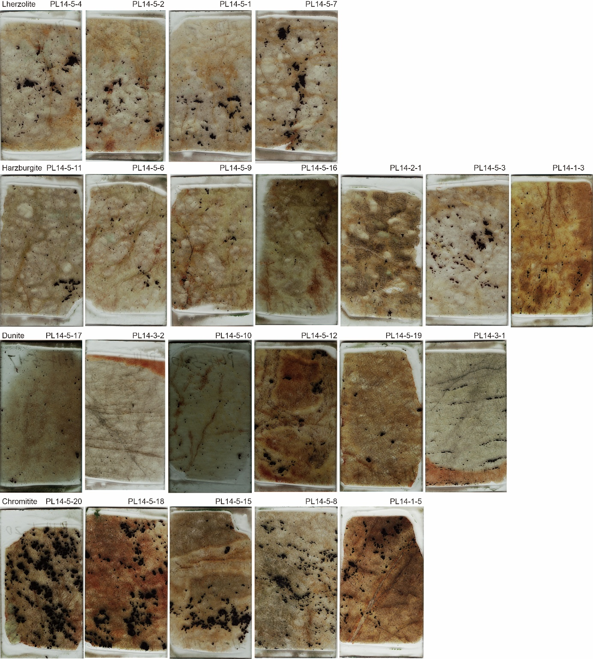
Fig. S1 Scanned thin-section images of all studied samples from Purang ophiolite.

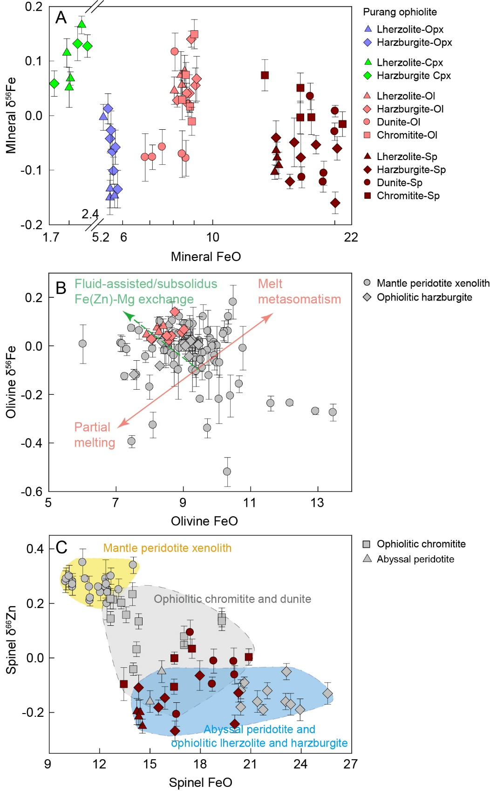
Fig. S2 Plots of FeO vs. δ⁵⁶Fe (A) for all minerals from Purang ophiolitic rocks and (B) for olivine from mantle peridotite xenoliths and ophiolitic lherzolites and harzburgites. (C) Plot of FeO vs. δ⁶⁶Zn for spinel from mantle peridotite xenoliths, ophiolitic rocks, and abyssal peridotites. Data sources are same as in Fig. 3.

