Supplementary Information:
Dependence of river water lithium isotope ratios on watershed attributes complicates interpretation of weathering-driven CO₂ drawdown

Evan J. Ramos^{1*}, Preston Cosslett Kemeny², Mark A. Torres³, Tomas N. Capaldi⁴

¹Department of Geology and Environmental Science, University of Pittsburgh, Pittsburgh, PA 15260 USA
²Department of the Geophysical Sciences, University of Chicago, Chicago, IL 60637 USA
³Department of Earth, Environmental and Planetary Sciences, Rice University, Houston, TX 77005 USA
⁴Scripps Institution of Oceanography, UC San Diego, La Jolla, CA 92037 USA

*corresponding author: evan.j.ramos@pitt.edu

Table of contents:

Text sections:

S.1: Evaluation of bedrock Li/Na ratios
S.2: Hydrothermal fluid impact on river Li isotope ratios

Tables:

S.1: Evaluation of inversion performance.

Figures:

S.1: Correlation plots and histograms of all continuous catchment variables
S.2: Distribution of rock Li/Na values for watersheds grouped by dominant rock type
S.3: Histograms of median $F_{clay}^{Σ^{±}}$ values (fraction solute uptake by clay relative to source supply)
S.4: Comparison of median $F_{clay}^{Σ^{±}}$ to solute specific median $F_{clay}^{}$ (Mg, Li, Ca)
S.5: Inversions results with and without hydrothermal fluid sources
S.6: Calculating the influence of hydrothermal Li input on $f_{{diss}_{}}^{Li}$and Δ⁷Li_{river-rock} values
S.7: Hydrothermal Li, δ⁷Li, silicate weathering intensity, and inversion results
S.8: Distribution of median Li content in clay
S.9: Impacts of δ⁷Li_{clay} and δ⁷Li_{rock} on δ⁷Li_{river} values
S.10: Distributions of inverted median δ⁷Li_{rock} values
S.11: Model sensitivity to weathering zone thickness
S.12: Impact of clay mineral dissolution rates on steady state $f_{{diss}_{}}^{Li}$ and Δ⁷Li_{river-rock} values
S.13: Impact of climate on steady state $f_{{diss}_{}}^{Li}$ and Δ⁷Li_{river-rock} values

S.1: Evaluation of bedrock Li/Na ratios
To understand the underlying drivers of Li isotope fractionation and clay cation uptake, we first consider the inverted bedrock composition for each sample in the dataset, focusing on the base inversion. To first order, we find that the distribution of median inversion-constrained bedrock Li/Na ratios is largely invariant across watersheds over varying lithology (fig. S.2). Inverted bedrock Li/Na ratios for the entire dataset span over a three order of magnitude range, from ~10⁻³ to ~3, and can appear normally distributed when log-transformed. The median bedrock Li/Na ratio is equal to 1.5x10⁻² (1.0 x 10⁻² for just silicates), several factors larger than estimates of Li/Na for UCC (4x10⁻³; Rudnick and Gao, 2003; Sauzeat et al., 2015). The variability in distributions of bedrock Li/Na are such that volcanic watersheds have subtly lower median bedrock Li/Na than all other groups and watersheds with dominantly sedimentary rocks, loose sediment, or mixed lithology have comparable bedrock Li/Na that is subtly higher than the volcanic rock distribution. Plutonic watersheds show a strong unimodal distribution of high bedrock Li/Na compared to other lithologies. It is worth noting though that the number of plutonic watersheds (n = 44) is lower than other bedrock types. The range in median values across each bedrock type (about 10⁻² to 4x10⁻²) is substantially narrower than the absolute range of bedrock Li/Na in the dataset. The comparable overlap in bedrock Li/Na ratios suggest that river water Li/Na may be useful itself for evaluating weathering congruency and clay Li uptake.

S.2 Hydrothermal fluid impact on river Li isotope ratios
Our inversions attempt to reconcile inputs of hydrothermal fluids on river water Li isotope compositions. The results show that when included as an endmember, hydrothermal fluids can be the predominant source of Li to river water. Yet, these same inversions often show that hydrothermal fluids do not compose a significant proportion of the net solute load (fig. 6; main text), indicating that the inversion solutions are representing hydrothermal fluids as strictly a Li source. This outcome does not meet a reasonable expectation because a fluid with high Li concentrations may also contain high concentrations of other mono- and divalent cations. Instead, these inversion results arise because of our broad endmember definition of hydrothermal fluids, which points to the need for better definitions. In practice, however, applying strict definitions of a hydrothermal endmember for a global dataset is haphazard for several reasons. For instance, hydrothermal fluids can have varying Li contents (spanning > 4 orders of magnitude) and varying δ⁷Li values over a few kilometers within an orogen, which may be partly due to the lithology of the rock in which the hydrothermal system is hosted (Helper et al., 2023). In addition to spatial variability, hydrothermal fluids at given location can change in association with changing tectonic or volcanic activity. Studies that can reconcile the inputs of hydrothermal fluids (e.g., Cole et al., 2022; J.W. Zhang et al., 2022) have locality-specific constraints on their composition that inform reasonable attributions of hydrothermal fluid impact on river chemistry. We therefore encourage that if hydrothermalism is detected or suspected of occurring in each locality, geochemical characterization of such fluids will be an important step in gleaning weathering signals from river solute chemistry.
Despite these challenges, we offer some hope for extracting weathering signals from hydrothermally impacted watersheds. Firstly, the inclusion of hydrothermal endmembers does not systematically or greatly impact change to inverted δ⁷Li_{clay} values (fig. S.4), given how well the median values of each inversion correlate with one another. In addition, the changes in Δ⁷Li_{clay-water} values between inversions for each sample does not relate to the fraction of Li or other solute a hydrothermal fluid contributes to river water, implying that a combination of factors are needed to address changes in δ⁷Li_{clay} values. These observations lend confidence that in a statistical sense, the influence of hydrothermal fluids on δ⁷Li_{clay} values is mostly minimal or imperceptible.
Lastly, we demonstrate that with a modified steady state equation for the fraction of Li remaining in solution $f_{{diss}_{∞}}^{Li}$ that accounts for hydrothermal fluid inputs, the net impact on Δ⁷Li_{river-rock} values can be quantified and should be minimal. We can define a hydrothermal Li flux $J_{Li,hydro}$ (mass⋅time⁻¹) as
$$J_{Li,hydro}=k_{hydro}{⋅M}_{hydro}⋅{Li}_{hydro}$$ | (S.1)
where $k_{hydro}$ corresponds to the rate of hydrothermal input and the product $M_{hydro}{Li}_{hydro}$ is the total Li mass of hydrothermal fluid where $M_{hydro}$ is the mass of hydrothermal fluid (M) and ${Li}_{hydro}$ is the concentration of Li in this fluid (M M⁻¹). Adding eq. (S.1) as an additional flux to the righthand side of eq. (28) (main text), we arrive at a modified version of $f_{{diss}_{∞}}^{Li}$ that shows
$$f_{{diss}_{∞}}^{Li}=\frac{k_{erosion}+k_{clay,weathering} }{{k_{erosion}D}_{clay}^{Li}k_{clay,formation}}⋅\left(k_{slct,weathering}+ \frac{{(k}_{erosion}+k_{slct,weathering})}{k_{erosion}}k_{hydro}γ_{hydro}\right)$$ | (S.2)
where $γ_{hydro}$ corresponds to the mass of Li from hydrothermal fluids relative to silicates in bedrock, expressed as
$$γ_{hydro}=\frac{M_{hydro}{Li}_{hydro} }{M_{silicate,bedrock}{Li}_{slct}}.$$ | (S.3)
We surmise that hydrothermal fluids, in line with observations of areas of active uplift (J.W. Zhang et al., 2022), will be most prominent in areas of high relief and low weathering intensity. Therefore, we can reduce $f_{{diss}_{∞}}^{Li}$in the limit of $k_{supply}→∞$ to
$$\min\left(f_{{diss}_{∞}}^{Li}\right)=\frac{k_{silicate,weathering}+ k_{hydro}γ_{hydro} }{D_{clay}^{Li}k_{clay,formation}}.$$ | (S.4)
We designate this quantity as a minimum because of the observed minima that occur for $f_{{diss}_{∞}}^{Li}$ values with increasing $k_{supply}$ (fig. S.4). Here, eq. (S.4) shows that excess Li from a hydrothermal fluid, $k_{hydro}γ_{hydro}$, will cause the value of $\min\left(f_{{diss}_{∞}}^{Li}\right)$ to increase. The sensitivity of this input is shown in figure 16. If we assume values of $D_{clay}^{Li}$ (1000 ppm⋅ppm⁻¹) and $k_{clay,formation}$ ($0.10×k_{slct,weathering}$) and Rayleigh fractionation of Li isotopes (a mode more sensitive to $f_{diss}^{Li}$ than batch fractionation), we find that the impact of hydrothermal fluids on a perceived Δ⁷Li_{river-rock} value is mostly small until hydrothermal fluids constitute 50% of the net Li source to rivers. Even then, a decrease of 4 ‰ in Δ⁷Li_{river-rock} values due to hydrothermal fluid inputs at proportions of 50% is comparable in magnitude to, for instance, the difference δ⁷Li_{rock} values for some samples across inversion schemes. We postulate too that there would be other noticeable impacts on a river sample with 50% hydrothermal Li, such as elevated water temperature or high total dissolved solids, that would hazard the usage of this sample to investigate chemical weathering. Nevertheless, the magnitude of change from hydrothermal impact can be magnified in watersheds that contain clay minerals that form sluggishly (low $k_{clay,formation}$) or weakly incorporate Li (low $D_{clay}^{Li}$), meaning that lower proportions of hydrothermal fluid Li are needed to drive a similar decrease in δ⁷Li_{river} values. In this way, the sensitivity of hydrothermal fluid input to river Li isotope compositions is modulated by the geology and physiography of a watershed and the weathering it engenders. Overlooking the role of hydrothermal fluid, as the schematic framework J.W. Zhang et al. (2022) implies, may result in an underestimation of the degree of clay mineral formation in low weathering intensity regimes. Although our inversion with hydrothermal fluids does not make the case for hydrothermal fluid Li underlying trends between Δ⁷Li_{river-rock} and silicate weathering intensity (fig. S.6), the increased sensitivity of river solute chemistry to hydrothermal fluids in low weathering intensity environments remains a formal possibility.

TABLES
Table S.1 Evaluation of inversion performance.
Inversion scheme | Percentage of samples with one or more acceptable inversions | Percentage of samples with 200** acceptable inversions | Statistics for samples with at least one acceptable inversion
Inversion scheme | Percentage of samples with one or more acceptable inversions | Percentage of samples with 200** acceptable inversions | Median | Mean | Minimum
Base | 98.6 | 59.3 | 200 | 166 | 3
Base +hydrothermal | 99.5 | 85.3 | 200 | 190 | 1
**200 corresponds to the maximum number of acceptable inversions

FIGURES
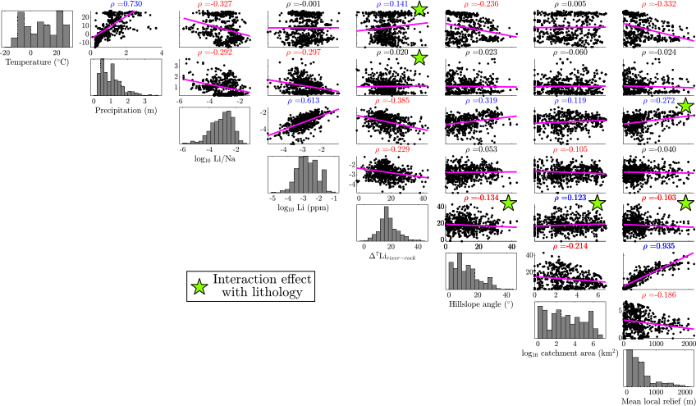
Figure S.1: Correlation plots and histograms of all continuous catchment variables. All bivariate plots found in each row contain the same variable on the y-axis whereas each column contains that variable on the x-axis. Magenta lines represent least squares linear regressions and all values in the title of bivariate plots are Spearman’s ρ. where values > 0.1 have a significant monotonic relationship that are either positive (blue), negative (red) correlations, or are < 0.1 and lack a significant monotonic relationship (black). Green stars indicate a significant interaction effect of a catchment variable and lithology on river water chemistry, as determined by ANOVA (p-value < 0.05). The main observation we convey is that Δ⁷Li_{river-rock} values (5th columns) are not well-correlated with climate or geomorphic variables, but ANOVA results suggest that the coupling of lithology with either climate or geomorphic variables can significantly describe Δ⁷Li_{river-rock} values.
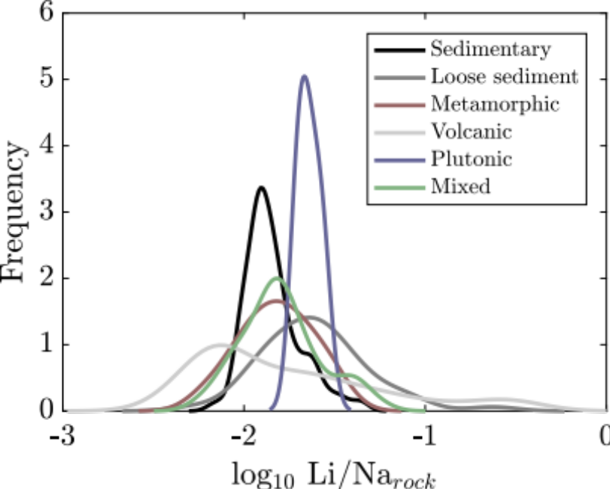
Figure S.2: Distribution of median rock Li/Na ratios for all samples grouped according to dominant bedrock type. The distributions overlap considerably, with plutonic watersheds having the narrowest range of rock Li/Na ratios and volcanic watersheds having the lowest mode Li/Na ratio.

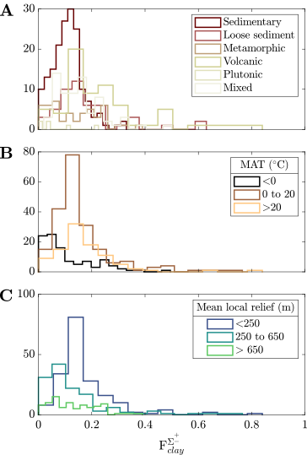
Figure S.3: Histograms of median $F_{clay}^{Σ^{±}}$ values (total solute uptake by clay relative to mineral source supply) for the base inversion with observations grouped categorically according to (A) dominant bedrock type, (b) MAT, and (C) mean local relief. The histograms with each categorical grouping have overlap in their modes.

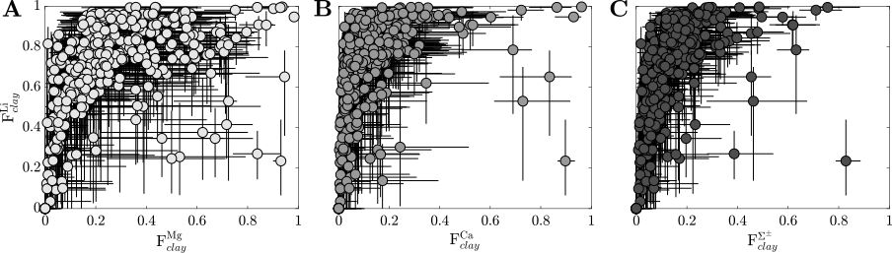
Figure S.4: Comparison of median solute uptake fractions (clay uptake relative to source release) $F_{clay}^{Li}$ with $F_{clay}^{Mg}$ (A), $F_{clay}^{Ca}$ (B), and $F_{clay}^{Σ^{±}}$(C) for the base inversion. Error bars in both span the interquartile range. High fractions of Li uptake coincide with high fractions of Ca, Mg, and bulk solute uptake, but the relative mobility of Li diverges from major solutes.

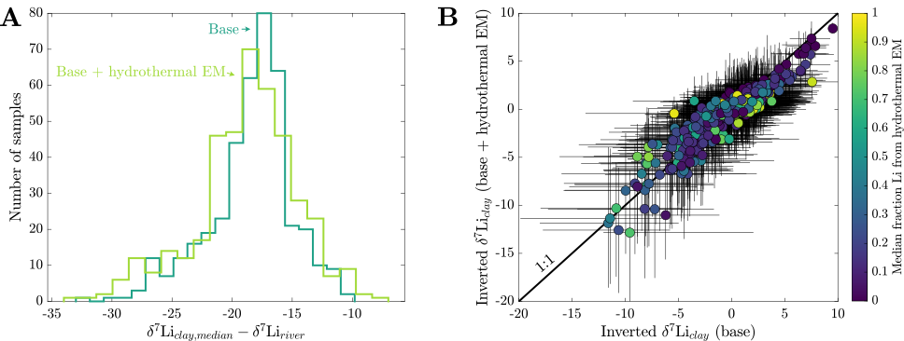
Figure S.5: (A) Histogram of Δ⁷Li_{clay-water} values for inversions with and without hydrothermal fluid sources. There is substantial overlap in values and consistent modes between the inversions (within 2 ‰ of one another). (B) Cross plot of inverted δ⁷Li_{clay} values for inversions with and without a hydrothermal fluid. The black line is the 1:1 line and the color of the symbol corresponds to the fraction of Li sourced from hydrothermal fluids (source values renormalized to range between 0 and 1). The strong correlation between the inverted δ⁷Li_{clay} values and the absence of a relationship with Li contributions from hydrothermal fluids points suggest that hydrothermal fluid inputs do not readily impact inferences of weathering-related Li isotope transfer. Error bars in B reflect the interquartile range of accepted inversion results.
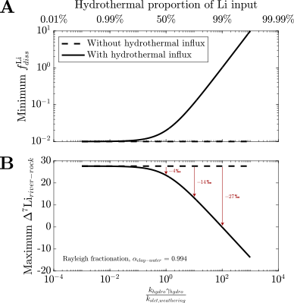
Figure S.6: Calculating the influence of hydrothermal Li input on (A) $f_{diss}^{Li}$ and (B) Δ⁷Li_{river-rock} values in environments with low weathering intensities. Curves show the minimum possible $f_{diss}^{Li}$ value (i.e., in the limit of $k_{supply}→∞$) and corresponding maximum Δ⁷Li_{river-rock} values as a function of the relative contribution of hydrothermal Li to river water. Dashed lines are reference values correspond to compositions without a hydrothermal influx of Li and solid lines are the corresponding values with variable hydrothermal Li input. All calculations of Δ⁷Li_{river-rock} as a function of $f_{diss}^{Li}$ assume Rayleigh fractionation (eq. 38; main text) and a fractionation factor between clay and water Δ⁷Li_{clay-river} = -6 ‰. This mode of fractionation is more sensitive to $f_{diss}^{Li}$ than batch fractionation, meaning these results show a maximum sensitivity. There is a corresponding decrease in Δ⁷Li_{river-rock} with increasing hydrothermal Li input.
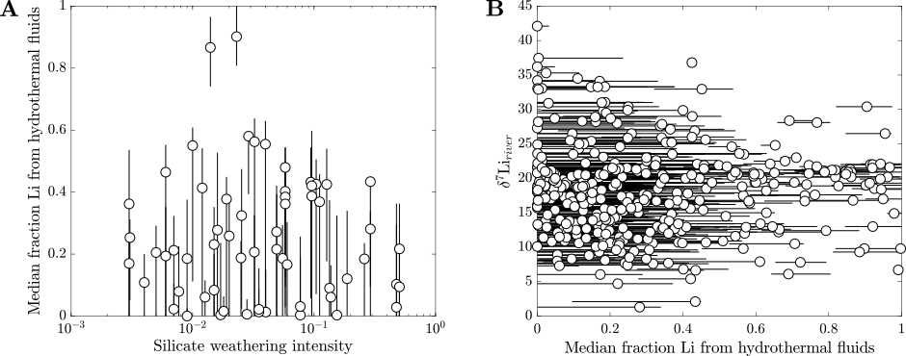
Figure S.7: (A) The relationship between fraction of Li from hydrothermal fluids (base + hydrothermal endmember inversion) and reported silicate weathering intensity from Dellinger et al. (2015). (B) Reported δ⁷Li_{river} values against the median fraction of Li from hydrothermal fluids for the same inversion scheme as panel A. Error bars in both span the interquartile range. The lack of a correlation in both panels suggests that hydrothermal Li input may not play a prominent role in the relationship between silicate weathering intensity and δ⁷Li_{river} values.

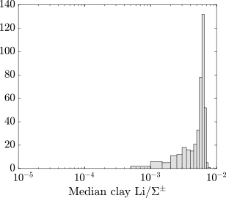
Figure S.8: Distribution of inversion-constrained median clay Li/$Σ^{±}$ for the base inversion. The bounds for the x-axis span the Li prior range for the clay endmember, showing a preference for clays with higher Li content.
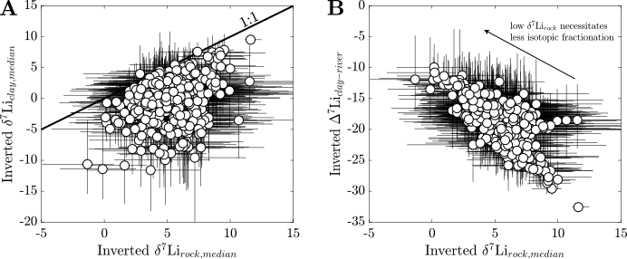
Figure S.9: Impacts of δ⁷Li_{clay} and δ⁷Li_{rock} on δ⁷Li_{river} values. (A) Comparison of inverted δ⁷Li_{clay} and δ⁷Li_{rock} values (error bars span the interquartile range). The δ⁷Li_{clay} and δ⁷Li_{rock} values show very little correlation. (B) Comparison of Δ⁷Li_{clay-river} values and δ⁷Li_{rock} values have a negative correlation. The latter supports the idea that river water that is heavily fractionated by clay mineral formation but could be accommodated or partly driven by changing δ⁷Li_{rock} values.
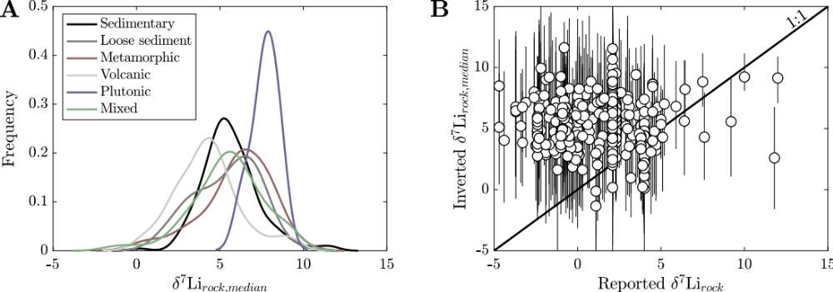
Figure S.10: (A) Distributions of inverted median δ⁷Li_{rock} values for the base inversion grouped according to exposed bedrock type. There is appreciable overlap in distributions, with a decrease in the mode for watersheds dominated by loose sediment and an increase in the mode for plutonic watersheds. (B) Inverted median δ⁷Li_{rock} values (with error bars showing the interquartile range) against reported estimates of δ⁷Li_{rock} values with a 1:1 line shown. The inversion-constrained δ⁷Li_{rock} values are systematically higher than those reported for most samples.
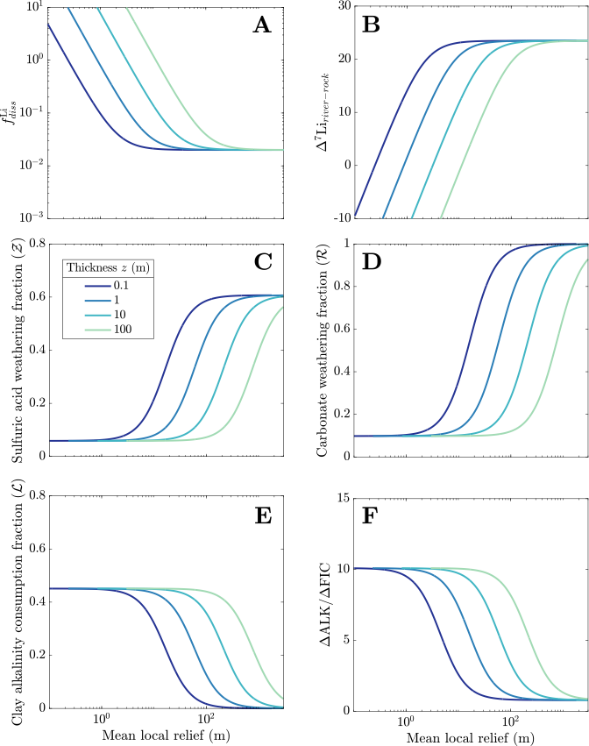
Figure S.11: Sensitivity of Li isotope transfer (A, B) and acid-alkalinity budget of weathering due to changes (C-F) in weathering zone thickness. and the charge of silicate cations generated during weathering. Increases in weathering zone thickness cause the rate of $k_{erosion}$ to decrease, causing all curves in mean local relief space to translate rightward. All constants used in the calculations: $γ_{carb}$ = 0.05; $γ_{sulf}$ = 0.03; $k_{clay,formation}=0.5×k_{silicate,weathering}=2×k_{clay,weathering}=5×{10}^{-7}$ yr⁻¹, $k_{sulf,weathering}=k_{carb,weathering}={10}^{0}$ yr⁻¹; ; $ν_{slct}=ν_{clay}=1$; $D_{clay}^{Li}=100$; α_{clay-water} = 0.994 (Rayleigh fractionation); MAT = 15 °C and MAP = 4000 mm.
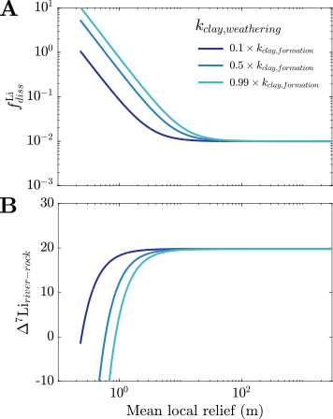
Figure S.12: Impact of $k_{clay,weathering}$ on steady state $f_{diss}^{Li}$ (A) and Δ⁷Li_{river-rock} values (B). Steady state Δ⁷Li_{river-rock} values assume batch fractionation. Increases in $k_{clay,weathering}$ drive Δ⁷Li_{river-rock} values low across at low relief but have no impact at high relief ($k_{erosion}≫ k_{clay,weathering}$). All constants used in the calculations: $γ_{carb}$ = 0.05; $γ_{sulf}$ = 0.03; $k_{clay,formation}=0.5×k_{silicate,weathering}=5×{10}^{-7}$ yr⁻¹; $D_{clay}^{Li}=100$; α_{clay-water} = 0.980.

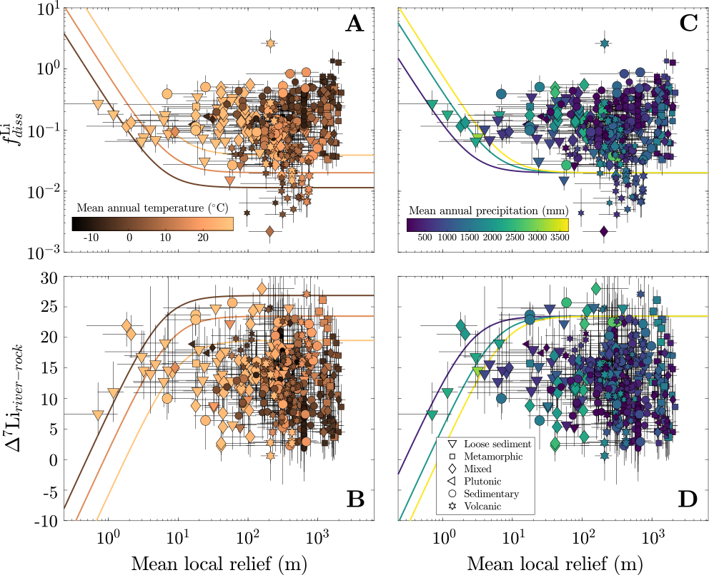
Figure S.13: Impact of mean annual temperature (MAT) and mean annual precipitation (MAP) on steady state $f_{diss}^{Li}$ (A, C) and Δ⁷Li_{river-rock} values (B, D). All symbol colors correspond to water MAT and MAP, and all error bars span the interquartile range of inversion results. Steady state Δ⁷Li_{river-rock} values assume Rayleigh fractionation. Increases in MAT drive Δ⁷Li_{river-rock} values low across all ranges of relief whereas increases in MAP (assumed equal to infiltration rate) drive Δ⁷Li_{river-rock} values low at relief values < 10 m. All constants used in the calculations: $γ_{carb}$ = 0.05; $γ_{sulf}$ = 0.03; $k_{clay,formation}=0.5×k_{silicate,weathering}=2×k_{clay,weathering}=5×{10}^{-7}$ yr⁻¹, $k_{sulf,weathering}=k_{carb,weathering}={10}^{0}$ yr⁻¹; $D_{clay}^{Li}=100$; α_{clay-water} = 0.994.

REFERENCES CITED
Cole, T. L., Torres, M. A., & Kemeny, P. C. (2022). The hydrochemical signature of incongruent weathering in Iceland. Journal of Geophysical Research: Earth Surface, 127(6), e2021JF006450. DOI: 10.1029/2021JF006450
Dellinger, M., Gaillardet, J., Bouchez, J., Calmels, D., Louvat, P., Dosseto, A., ... & Maurice, L. (2015). Riverine Li isotope fractionation in the Amazon River basin controlled by the weathering regimes. Geochimica et Cosmochimica Acta, 164, 71-93. DOI: 10.1016/j.gca.2015.04.042
Giggenbach, W. F. (1988). Geothermal solute equilibria. derivation of Na-K-Mg-Ca geoindicators. Geochimica et cosmochimica acta, 52(12), 2749-2765. DOI: 10.1016/0016-7037(88)90143-3
Helper, J. P., Barnes, J. D., de Moor, J. M., Rodríguez, A., Barry, P. H., Ramos, E. J., & Lassiter, J. C. (2023). Li isotope ratios of spring fluids as an effective tracer of slab-derived subducted sources across the Costa Rica forearc. Geology, 51(9), 855-859. DOI: 10.1130/G51277.1
Tomascak, P. B., Magna, T., & Dohmen, R. (2016). Advances in Lithium Isotope Geochemistry, 19 pp. Berlin: Springer. DOI: 10.1007/978-3-319-01430-2

Zhang, J. W., Yan, Y. N., Zhao, Z. Q., Liu, X. M., Li, X. D., Zhang, D., ... & Liu, C. Q. (2022). Spatiotemporal variation of Li isotopes in the Yarlung Tsangpo River basin (upper reaches of the Brahmaputra River): Source and process. Earth and Planetary Science Letters, 600, 117875. DOI: 10.1016/j.epsl.2022.117875

