SUPPLEMENTARY MATERIALS: Heterogeneous lithium isotope records across the end-Permian mass extinction as an indicator for a highly perturbed lithium cycle

Alternative explanations for the siliciclastic δ⁷Li record

This study compares new carbonate δ⁷Li records with published siliciclastic δ⁷Li records from Rauzi et al. (2024). The siliciclastic δ⁷Li record and how it is interpreted is described in detail in that study, but we provide further context to consider alternative explanations for those data.
Other non-silicate material present in siliciclastic sediments (e.g., organic matter, oxide minerals) is not expected to influence the δ⁷Li of marine siliciclastic archives due to their low Li content (<3 ppm Li; e.g., Yang et al., 2023) and relative mass fraction (<5 wt%), relative to Li-rich (10-100’s ppm Li, Pogge von Strandmann et al., 2020), abundant silicate minerals (>85 wt%). Specifically, the Li content of organic material (<1 ppm; Clergue et al., 2015, Li et al., 2020) and Fe-Mn oxides (<3 ppm; Yang et al., 2023, Liu et al., 2022, 2023; Shan et al., 2024) is significantly lower than that of silicate minerals (10-100’s ppm; Pogge von Strandmann et al., 2020). When considering the content of marine siliciclastic sediments, organic material and oxides comprise <1% and <5% of marine siliciclastic sediments by mass, respectively (Yaalon, 1961, Shaw & Weaver, 1965). Using these constraints, the maximum Li contribution from organic matter to total Li is <0.01%, and the maximum Li contribution from oxide contribution to total Li is <0.20%. Based on this reasoning, we follow previous work (e.g., Pogge von Strandmann et al., 2017, 2021; Wei et al., 2020, 2024; Rauzi et al., 2024) and interpret the Li content and isotope composition of marine siliciclastic sediments as reflecting that of the silicate mineral fraction.
It is possible that post-lithification alteration could modify the δ⁷Li value of siliciclastic records; however, there is not yet any data that would indicate this would result in a systematic positive isotope shift. For example, low-grade metamorphism (schist facies and below) has a negligible effect on the δ⁷Li value of marine siliciclastic archives (Penniston-Dorland et al., 2012). Nonetheless, diagenetic alteration of siliciclastic sediments is important to consider. We also examine the assumption that the siliciclastic δ⁷Li values must represent a minimum bound on the fluid δ⁷Li value. Experiments indicate that the Li isotopic fractionation between clay minerals and precipitating fluid is always less than or equal to 0‰ (Hindshaw et al., 2019). This is supported by reactive transport modeling that also suggests that, even at very high clay formation rates, the δ⁷Li value of the precipitating clay is less than that of seawater (Li et al., 2021). The modeling results support the hypothesis that during the Precambrian, when the Li reservoir was small, the isotope offset during clay formation approached 0‰ (Kalderon-Asael et al., 2021).
Clays with δ⁷Li values higher than the source fluid can form in terrestrial settings. In these cases, weathered bulk regolith and suspended riverine sediments sometimes exhibit δ⁷Li values higher than upper continental crust and/or the δ⁷Li value of the fresh bedrock (Dellinger et al., 2017; Chapela Lara et al., 2022). This outcome is possible in terrestrial systems that are advection dominated (e.g., Péclet number >1, where the Péclet number, Pe = uL/Ds and u = advective velocity, L = characteristic length scale, and D_{s} is the diffusion coefficient in sediments). These systems can be approximated using Rayleigh distillation equations, where the δ⁷Li value of the instantaneous product (in this case the secondary clays) has the potential to be very high (Fig. S7). Under this scenario, upon isotope fractionation of ⁷Li/⁶Li during clay authigenesis, the ⁷Li-enriched fluid is advected from the reaction site, and secondary clay mineral formation along the flow path can take up this Li with a consequently higher δ⁷Li values than the original fluid, which should reflect the bedrock isotopic signature.
Diagenetic regimes in marine sediments are generally assumed to be diffusion dominated (Berner, 1980; Burdige, 2006). This situation results from two possible physical phenomenon: (1) the permeability of fine-grained sediments is very low compared to coarser grained sediments, which limits the potential for externally impressed advective flow (e.g., Burdige, 2006), even in the presence of groundwater or hydrothermal flow, and (2) the primary means of advective flow in marine settings—bottom-water currents and high compaction rates from fast sedimentation—are thought to be rare (high compaction rates from very high sedimentation rates) or limited in their ability to penetrate deep in the sediment column (porewater advection limited to uppermost ~10 cm even at moderate permeability; Burdige, 2006). Where diffusion is dominant, the effective Li isotope fractionation from clay authigenesis at the seafloor cannot result in clay δ⁷Li values higher than that of seawater (Li et al., 2021)—an outcome that is also predicted for other diffusion-dominated isotope fractionation in groundwater systems (e.g., Se isotopes; Clark & Johnson, 2008) and in biogeochemical reduction during early marine diagenesis (e.g., U isotopes; Lau et al., 2020). Based on Rayleigh principles and riverine observations, however, it should be considered whether environments exist in marine sedimentary systems with high diagenetic fluid advection rates that maintain open system behavior (e.g., Péclet number > 1) and thus influence the δ⁷Li signal of the siliciclastic sediments.
Advection-dominated sedimentary systems are expected in shallow settings where tidal forces, groundwater flow, precipitation, and differences in water mass density (salinity) drive flow. A classic example is dolomitization of shallow carbonate platforms, where advection is required to deliver a large enough flux of Mg to transform calcite to dolomite (e.g., Jones et al., 2002). These nearshore settings would be expected to have been dolomitized and potentially influenced by terrestrial clay input, however, and preservation of a dominantly authigenic clay signal would not be expected. Alternatively, hydrothermal vents—settings which are unlikely to be preserved in the sedimentary record—are characterized by advective fluid fluxes generated by the large temperature gradients that result in convective flow of seawater through the seafloor (e.g., Maris et al., 1984). High advective fluxes are not expected for typical marine shale or chert environments, and advection during diagenesis is also unlikely because fine-grained siliciclastic and chert environments typically have low permeability (Burdige, 2006). Specifically for the P/Tr δ⁷Li records, the highest siliciclastic δ⁷Li values occur in the Waiheke Island section from New Zealand (Fig. 6), which is interpreted as a pelagic deep-marine setting that should not have advective circulation and that does not contain evidence for substantial hydrothermal or diagenetic advective flow (based on the mineralogy of the site; Rauzi et al., 2024). Further, some high δ⁷Li values (i.e., that are higher than contemporaneous seawater as constrained from carbonate δ⁷Li values) occur in two other sections (Ubara, Japan and Lusitaniadalen, Svalbard), suggesting that the high δ⁷Li values from New Zealand do not reflect the Li isotope signatures expected from a confined, single locality (Rauzi et al., 2024).
From a reactive transport perspective, it is possible that authigenic clay δ⁷Li values in marine settings could be higher than seawater (Fig. S7) but adopting this interpretation would be speculative and not based on typical expectations from marine diagenetic modeling. Furthermore, most advection-dominated environments where this effect could be possible would also experience significant mixing with detrital Li (e.g., nearshore) or would not be expected to be readily preserved in the sedimentary rock record (e.g., hydrothermal sediments). Rather, a specific environment—with negligible detrital Li (e.g., pure carbonates or cherts) that is also advection-dominated—would result in this effect; these settings should be avoided for seawater composition reconstructions in future work. Nonetheless, this remains an important future direction that could be addressed by studies of modern coastal sediments in locations characterized by high advective fluid flow.
cGENIE Earth system model

We use the cGENIE Earth system model of intermediate complexity, which is based on a frictional-geostrophic approximation 3D ocean circulation model coupled to a fast 2D energy–moisture balance atmosphere and a dynamic–thermodynamic sea-ice component (Edwards & Marsh, 2005; Marsh et al., 2011). In all simulations, we adopt a published end-Permian paleogeographic configuration using a 36 × 36 equal-area horizontal grid with 16 depth levels in the ocean (Hülse et al., 2021). The concentration of the tracer is shown in Fig. 9 for the shallow ocean after the model is integrated for 5,000 years. The predicted precipitation patterns from Scotese (2014) and Li et al. (2022) show relatively arid conditions on the eastern margin of Pangea, which could result in a relatively smaller riverine Li flux to the western Tethys compared to the eastern Panthalassa Ocean. Continental sources off the eastern margin of the Paleo-Tethys Ocean are not simulated due to large uncertainties of the extent and morphology of subaerial landmasses. Additionally, the low spatial resolution of cGENIE may not accurately represent circulation in the Paleo-Tethys. Therefore, these simulations are not intended to track potential transport patterns applicable to Turkey or South China. Future work in cGENIE could include explicit modeling of Li isotopes in the ocean basins as a result of variable continental weathering (Adloff et al., 2021).

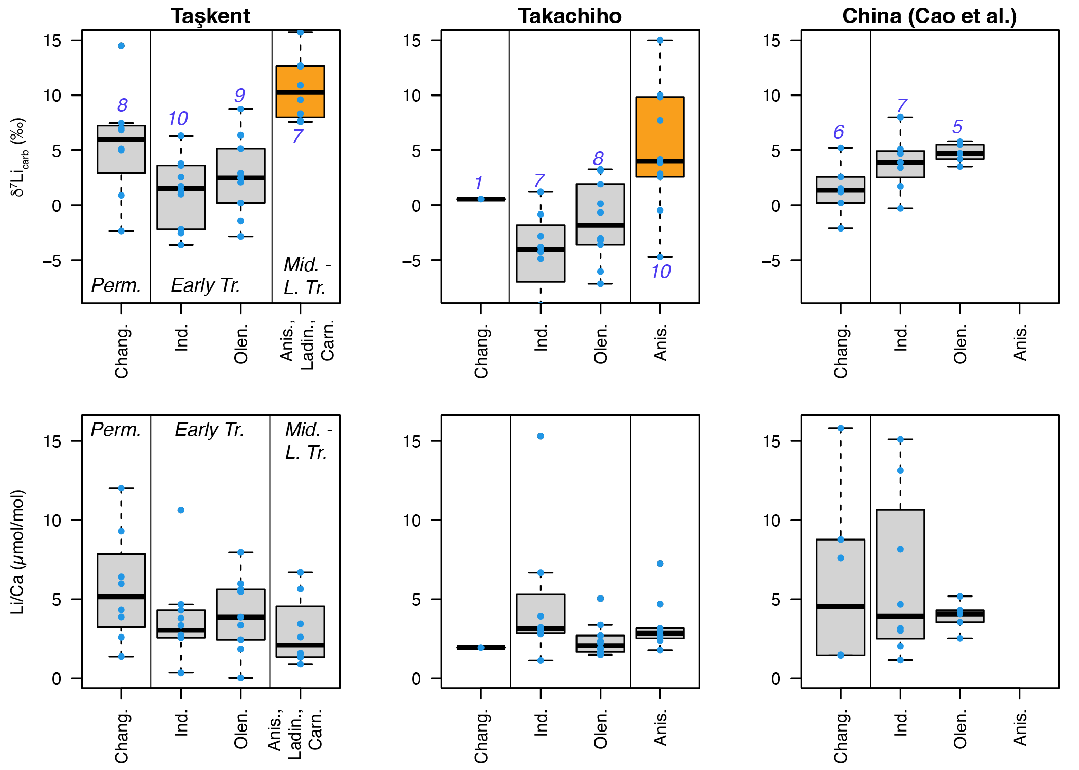
Figure S1. Box-and-whisker plots of carbonate δ⁷Li (top) and Li/Ca records (bottom) binned by stage. We compare three carbonate sections, two from this study (Taşkent, Turkey, and Takachiho, Japan) with previously published data from South China (Cao et al., 2022). Numbers in blue are the number of samples represented in each boxplot and data are shown as blue circles. The ANOVA analysis (Table S2) indicates that the δ⁷Li in the Anisian (orange) are significantly higher than the δ⁷Li of the preceding stages in Taşkent and compared to the Induan and Olenekian in Takachiho. Chang. = Changhsingian, Ind. = Induan, Olen. = Olenekian, Anis. = Anisian, Ladin. = Ladinian, Carn. = Carnian, Perm. = Permian, Early Tr. = Early Triassic, Mid.-L. Tr. = Middle to Late Triassic.

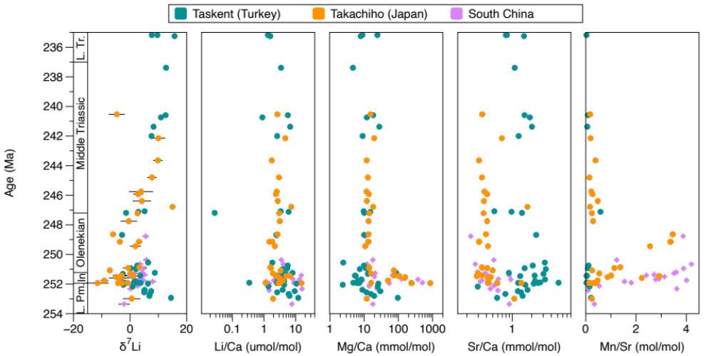 Figure S2. Combined geochemical data vs. age. Data from all three sections discussed in this study are presented. Taşkent (green) and Takachiho (orange) are from this paper, and Shanggang and Shangsi (South China, purple) are from Cao et al. (2022). Except for Mn/Sr, elemental ratios are shown on a logarithmic scale. L. Pm. = Late Permian, In = Induan, L. Tr. = Late Triassic.

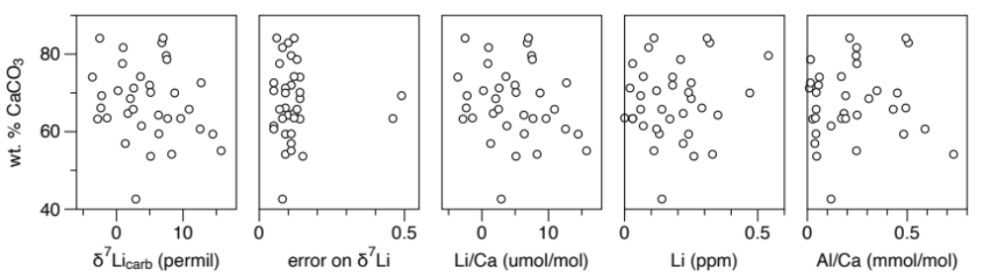
Figure S3. Carbonate content vs. key geochemical data. Data from Taşkent are compared to d⁷Li_{carb}, the 2SD of the analysis, Li/Ca ratios, Li concentrations, and Al/Ca ratios. Carbonate content is estimated from the sample mass and pressure observed during C and O isotope analysis. No relationship is observed between samples with lower carbonate content and Li isotope or concentration nor do we observe a relationship between Al concentration, as would be expected if the leach procedure was liberating siliciclastic Li.
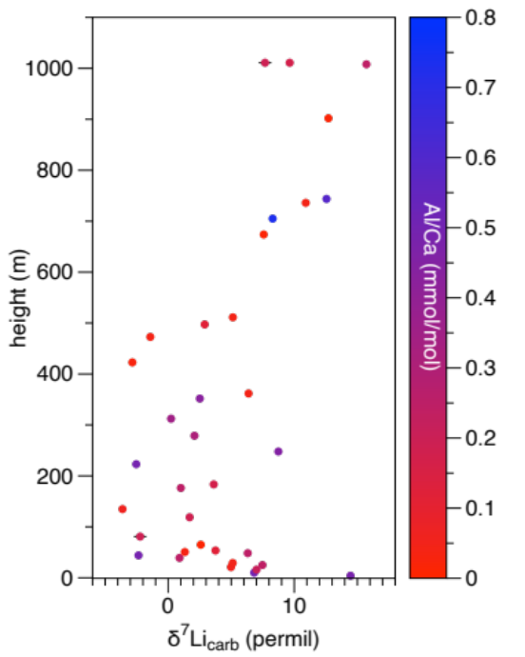
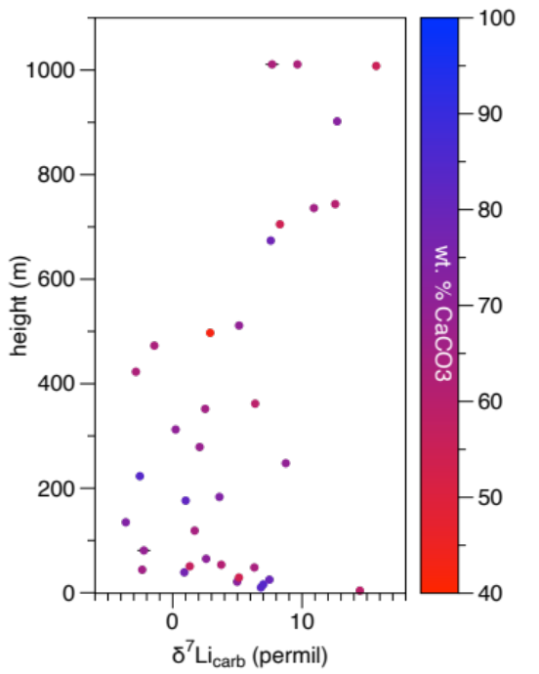
Figure S4. d⁷Li_{carb} from Taşkent as a function of the estimated carbonate content (left) and Al/Ca (right). The stratigraphic intervals with low d⁷Li_{carb} are not characterized by distinctly low/high carbonate contents or low/high Al/Ca.

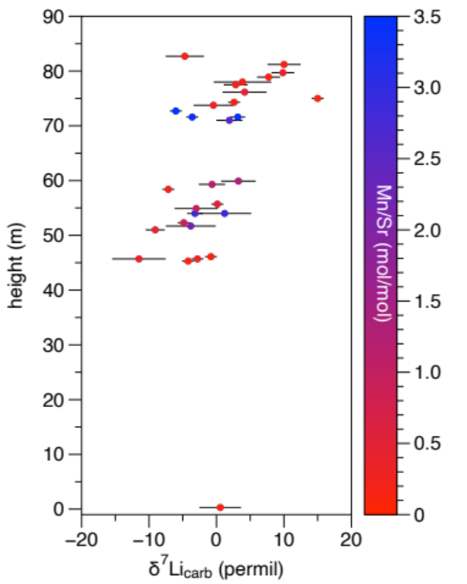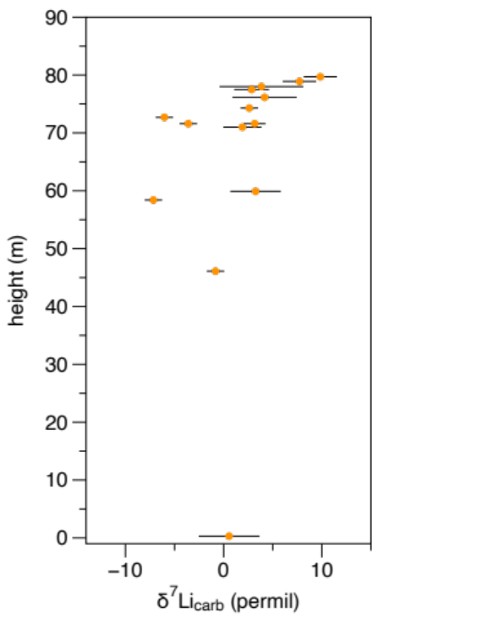
Figure S5. d⁷Li_{carb} from Takachiho (left) as a function of Mn/Sr ratios and (right) with a stricter Al/Ca cutoff of 0.12 mmol/mol. The stratigraphic intervals with low d⁷Li_{carb} are not characterized by high Mn/Sr. The observed pattern of low d⁷Li_{carb} in the Early Triassic (45 to 75 m) and an increase in the Middle Triassic (>75 m) is preserved in the dataset with the stricter cutoff.
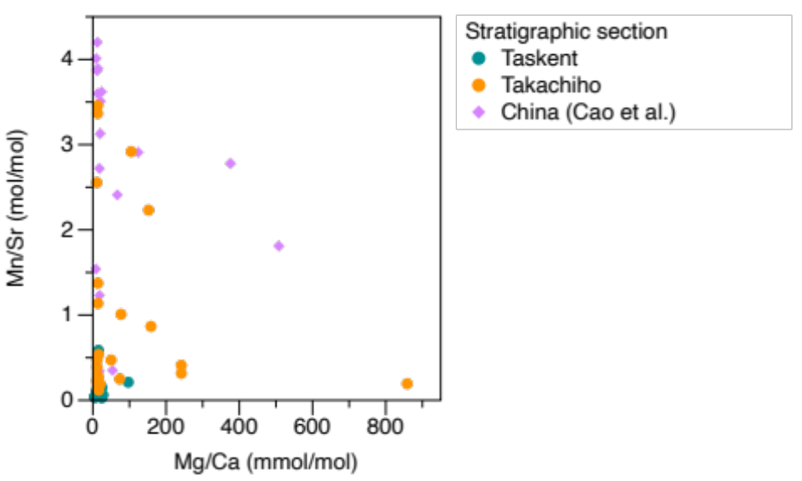
Figure S6. Comparison of Mn/Sr and Mg/Ca ratios. Data from all three sections discussed in this study are presented. Taşkent (green) and Takachiho (orange) are from this paper, and Shanggang and Shangsi (South China, purple) are from Cao et al. (2022).

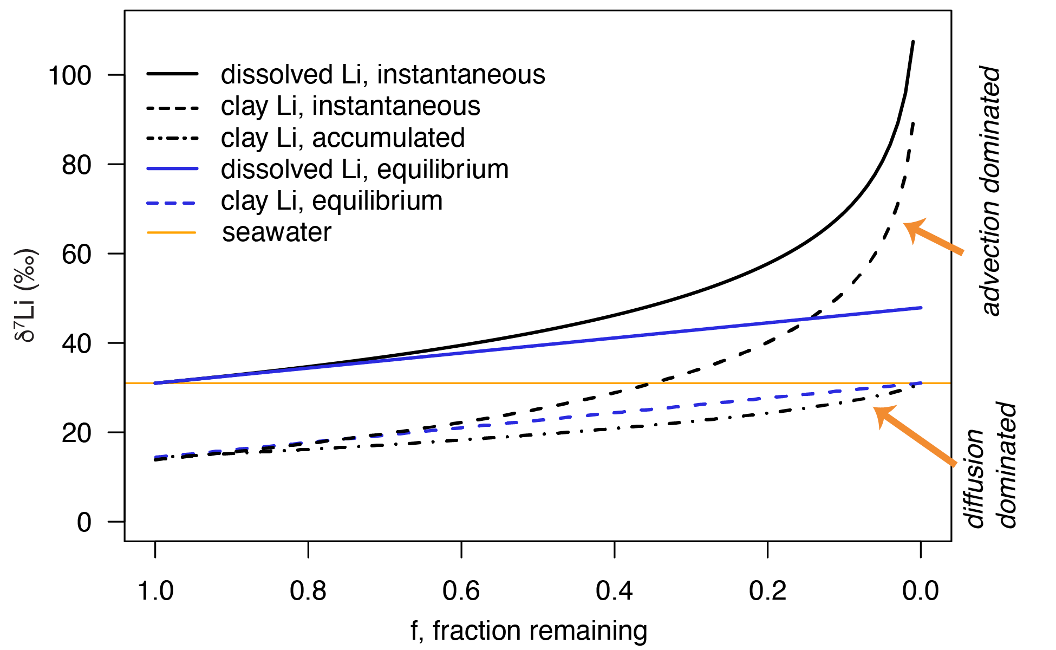
Figure S7. Rayleigh distillation modeling of δ⁷Li. The dissolved Li (solid lines) are shown relative to the accumulated and instantaneous clay product (dashed lines) for Rayleigh distillation (black lines) versus an equilibrium model (blue lines). For demonstration, the initial d⁷Li is the modern seawater value of 31‰.

Table S2. Summary of standards for Li isotope analyses. Uncertainty is reported as 2SD.
Standard | Yale | PSU | Accepted value
LSVEC | 0.46 ± 0.07 ‰ | 1.33 ± 1.77 ‰ | 0 ‰
IAPSO | 31.45 ± 0.07 ‰ | 30.45 ± 0.42 ‰ | 30.88 ± 0.12 ‰ (Huang et al., 2010)
SRM-3129a | NA | 6.75 ± 1.55 ‰ | 6.45 ± 0.60 ‰
bracketing standard | ± 0.36 ‰ | ± 0.58 ‰ | NA

Table S3. ANOVA results comparing δ⁷Li across stages for individual sections. Tukey-Kramer post-hoc test p-values are bolded if the ANOVA indicated statistically significant differences across stages (i.e., 𝛼 = 0.05). Mid/L. Tr = Middle to Late Triassic.
 | Taşkent, Turkey | Takachiho, Japan | South China (Cao et al., 2022)
ANOVA p-value | <0.001 | 0.001 | 0.052
Tukey-Kramer post-hoc test p-value
Changhsingian-Induan | 0.085 | 0.733 | --
Changhsingian-Olenekian | 0.385 | 0.973 | --
Changhsingian-Mid/L. Tr | 0.048 | 0.786 | --
Induan-Olenekian | 0.836 | 0.537 | --
Induan-Mid./L. Tr | <0.001 | 0.001 | --
Olenekian-Mid./L. Tr | <0.001 | 0.018 | --

Table S4. Correlation statistics. Spearman’s ρ results (including the p-value) are reported for δ⁷Li versus elemental ratios and Li/Ca versus elemental ratios for the sections in this study as well as Shanggang and Shangsi, South China (Cao et al., 2022). Significant results are bolded (𝛼 = 0.05).
 |  | Taşkent |  | Takachiho |  | South China
 |  | Spearman's ρ | p-value | Spearman's ρ | p-value | Spearman's ρ | p-value
δ⁷Li vs | Li/Ca | 0.17 | 0.34 | -0.16 | 0.39 | -0.60 | 0.01
δ⁷Li vs | Al/Ca | 0.08 | 0.65 | -0.44 | 0.02 | 0.08 | 0.75
δ⁷Li vs | Sr/Ca | -0.44 | 0.01 | -0.18 | 0.35 | -0.52 | 0.02
δ⁷Li vs | Mg/Ca | 0.34 | 0.04 | -0.55 | <0.01 | -0.62 | 0.01
δ⁷Li vs | Mn/Sr | -0.01 | 0.99 | -0.29 | 0.15 | 0.13 | 0.58
Li/Ca vs | Al/Ca | 0.64 | <0.001 | 0.57 | <0.01 | 0.24 | 0.32
Li/Ca vs | Sr/Ca | -0.16 | 0.36 | 0.26 | 0.17 | 0.38 | 0.11
Li/Ca vs | Mg/Ca | 0.48 | <0.01 | 0.58 | <0.01 | 0.71 | <0.01
 | Mn/Sr | 0.60 | 0.04 | -0.24 | 0.23 | 0.24 | 0.32

Table S5. Generalized linear model (GLM) of δ⁷Li vs. section, stage, and elemental ratios as additive predictors. The reference case for the categorical variables is Shanggang for section and Anisian for stage. Significant relationships (𝛼 = 0.05) are bolded. This analysis shows that, when accounting for mineralogical predictors (Sr/Ca, Li/Ca, and Mg/Ca), diagenesis (Mn/Sr), and for stage, the differences between sections are significant, with Shanggang and Taskent having higher δ⁷Li than Shangsi and Takachiho. Similarly, the differences in δ⁷Li between stages are significant, with δ⁷Li in the Anisian higher than other stages. This supports the ANOVA results (Tables S2 and S4). Last, we find that mineralogy, as accounted for with Sr/Ca, Li/Ca, and Mg/Ca, or diagenesis, as represented by Mn/Sr, cannot be the primary predictor of differences in δ⁷Li among sections or among stages.
Coefficient | Estimate | p-value
Intercept | 14.5 | <0.001
Section - Shangsi | -8.4 | 0.007
Section - Takachiho | -4.7 | 0.005
Section - Taşkent | 0.02 | 0.994
Stage - Changhsingian | -5.0 | 0.026
Stage- Induan | -8.4 | <0.001
Stage - Olenekian | -8.4 | <0.001
log₁₀(Sr/Ca) | 3.2 | 0.338
log₁₀(Li/Ca) | 3.4 | 0.251
log₁₀(Mg/Ca) | -2.6 | 0.097
log₁₀(Mn/Sr) | 2.6 | 0.144

Table S6. ANOVA results comparing δ⁷Li among sections. Tukey-Kramer post-hoc test p-values are reported if the ANOVA indicated statistically significant differences among stratigraphic sections (i.e., ANOVA p-value < 0.05). Significant relationships (𝛼 = 0.05) are bolded. Here, we compare the δ⁷Li from South China (Shangsi and Shanggang) separately but note that there are only 2 samples from Shangsi in the Changhsingian and 1 in the Induan (see Table 1).
 | Changhsingian | Induan | Olenekian | Middle-Late Triassic
ANOVA p-value | 0.227 | <0.001 | 0.005 | 0.024
Tukey-Kramer post-hoc test p-value
Shangsi-Shanggang | n/a | 0.542 | n/a | n/a
Shangsi-Taşkent | n/a | 0.971 | n/a | n/a
Shangsi-Takachiho | n/a | 0.622 | n/a | n/a
Shanggang-Taşkent | n/a | 0.971 | 0.506 | n/a
Shanggang-Takachiho | n/a | <0.001 | 0.007 | n/a
Taşkent-Takachiho | n/a | 0.006 | 0.034 | 0.024

REFERENCES
Adloff, M., Ridgwell, A., Monteiro, F.M., Parkinson, I.J., Dickson, A.J., Pogge Von Strandmann, P.A.E., Fantle, M.S., Greene, S.E., 2021. Inclusion of a suite of weathering tracers in the cGENIE Earth system model – muffin release v.0.9.23. Geosci. Model Dev. 14, 4187–4223. https://doi.org/10.5194/gmd-14-4187-2021
Berner, R.A., 1980. Early Diagenesis, Princeton Series in Geochemistry. Princeton University Press, Princeton, N.J.
Burdige, D.J., 2006. Geochemistry of Marine Sediments. Princeton University Press, Princeton, N.J.
Cao, C., Bataille, C.P., Song, H., Saltzman, M.R., Tierney Cramer, K., Wu, H., Korte, C., Zhang, Z., Liu, X.-M., 2022. Persistent late permian to early triassic warmth linked to enhanced reverse weathering. Nat. Geosci. 15, 832–838. https://doi.org/10.1038/s41561-022-01009-x
Chapela Lara, M., Buss, H.L., Henehan, M.J., Schuessler, J.A., McDowell, W.H., 2022. Secondary Minerals Drive Extreme Lithium Isotope Fractionation During Tropical Weathering. JGR Earth Surface 127, e2021JF006366. https://doi.org/10.1029/2021JF006366
Clark, S.K., Johnson, T.M., 2008. Effective Isotopic Fractionation Factors for Solute Removal by Reactive Sediments: A Laboratory Microcosm and Slurry Study. Environmental Science & Technology 42, 7850–7855. https://doi.org/10.1021/es801814v
Clergue, C., Dellinger, M., Buss, H.L., Gaillardet, J., Benedetti, M.F., Dessert, C., 2015. Influence of atmospheric deposits and secondary minerals on Li isotopes budget in a highly weathered catchment, Guadeloupe (Lesser Antilles). Chemical Geology 414, 28–41. https://doi.org/10.1016/j.chemgeo.2015.08.015
Dellinger, M., Bouchez, J., Gaillardet, J., Faure, L., Moureau, J., 2017. Tracing weathering regimes using the lithium isotope composition of detrital sediments. Geology 45, 411–414. https://doi.org/10.1130/G38671.1
Edwards, N. R., & Marsh, R. (2005). Uncertainties due to transport-parameter sensitivity in an efficient 3-D ocean-climate model. Climate dynamics, 24, 415-433Hülse, D., Lau, K.V., van de Velde, S.J., Arndt, S., Meyer, K.M., Ridgwell, A., 2021. End-Permian marine extinction due to temperature-driven nutrient recycling and euxinia. Nat. Geosci. 14, 862–867. https://doi.org/10.1038/s41561-021-00829-7
Jones, G.D., Whitaker, F.F., Smart, P.L., Sanford, W.E., 2002. Fate of reflux brines in carbonate platforms. Geology 30, 371–374. https://doi.org/10.1130/0091-7613(2002)030<0371:FORBIC>2.0.CO;2
Kalderon-Asael, B., Katchinoff, J.A.R., Planavsky, N.J., Hood, A. v. S., Dellinger, M., Bellefroid, E.J., Jones, D.S., Hofmann, A., Ossa, F.O., Macdonald, F.A., Wang, C., Isson, T.T., Murphy, J.G., Higgins, J.A., West, A.J., Wallace, M.W., Asael, D., Pogge von Strandmann, P.A.E., 2021. A lithium-isotope perspective on the evolution of carbon and silicon cycles. Nature 595, 394–398. https://doi.org/10.1038/s41586-021-03612-1
Lau, K.V., Lyons, T.W., Maher, K., 2020. Uranium reduction and isotopic fractionation in reducing sediments: Insights from reactive transport modeling. Geochim Cosmochim Acta 287, 65–92. https://doi.org/10.1016/j.gca.2020.01.021
Li, W., Liu, X.-M., Chadwick, O.A., 2020. Lithium isotope behavior in Hawaiian regoliths: Soil-atmosphere- biosphere exchanges. Geochimica et Cosmochimica Acta 285, 175–192.
Li, F., Penman, D., Planavsky, N., Knudsen, A., Zhao, M., Wang, X., Isson, T., Huang, K., Wei, G., Zhang, S., Shen, J., Zhu, X., Shen, B., 2021. Reverse weathering may amplify post-Snowball atmospheric carbon dioxide levels. Precamb Res 364, 106279. https://doi.org/10.1016/j.precamres.2021.106279
Liu, C., Pogge Von Strandmann, P.A.E., Tarbuck, G., Wilson, D.J., 2022. Experimental Investigation of Oxide Leaching Methods for Li Isotopes. Geostandard Geoanalytic Res 46, 493–518. https://doi.org/10.1111/ggr.12441
Maris, C.R.P., Bender, M.L., Froelich, P.N., Barnes, R., Luedtke, N.A., 1984. Chemical evidence for advection of hydrothermal solutions in the sediments of the Galapagos Mounds Hydrothermal Field. Geochim Cosmochim Acta 48, 2331–2346. https://doi.org/10.1016/0016-7037(84)90229-1
Marsh, R., Müller, S. A., Yool, A., & Edwards, N. R. (2011). Incorporation of the C-GOLDSTEIN efficient climate model into the GENIE framework:" eb_go_gs" configurations of GENIE. Geoscientific Model Development, 4(4), 957-992. Penniston-Dorland, S.C., Bebout, G.E., Pogge Von Strandmann, P.A.E., Elliott, T., Sorensen, S.S., 2012. Lithium and its isotopes as tracers of subduction zone fluids and metasomatic processes: Evidence from the Catalina Schist, California, USA. Geochim Cosmochim Acta 77, 530–545. https://doi.org/10.1016/j.gca.2011.10.038
Pogge Von Strandmann, P.A.E., Kasemann, S.A., Wimpenny, J.B., 2020. Lithium and Lithium Isotopes in Earth’s Surface Cycles. Elements 16, 253–258. https://doi.org/10.2138/gselements.16.4.253
Rauzi, S., Foster, W.J., Takahashi, S., Isson, T., 2024. Lithium isotopic evidence for enhanced reverse weathering during the Early Triassic warm period. Proc. Natl. Acad. Sci. 121(32), e23188601221. https://doi.org/10.1073/pnas.2318860121
Scotese, C.R., 2014b. Atlas of Phanerozoic Rainfall Maps (Mollweide Projection), Volumes 1-6,
PALEOMAP Atlas for ArcGIS, PALEOMAP Project, Evanston, IL.
Shan, E., Xiao, Y., Wang, Y.-Y., Tan, D., Sun, H., 2024. Lithium isotopic compositions of the Neoarchean Huoqiu BIF and the Paleoproterozoic Yuanjiacun BIF from North China Craton: Implications for the triggering mechanism of the Great Oxidation Event. Precambrian Research 411, 107527. https://doi.org/10.1016/j.precamres.2024.107527
Shaw, D.B., Weaver, C.E., 1965. The Mineralogical Composition of Shales. Journal of Sedimentary Petrology 35, 213–222.
Wei, G.-Y., Wei, W., Wang, D., Li, T., Yang, X., Shields, G.A., Zhang, F., Li, G., Chen, T., Yang, T., Ling, H.-F., 2020. Enhanced chemical weathering triggered an expansion of euxinic seawater in the aftermath of the Sturtian glaciation. Earth and Planetary Science Letters 539, 116244. https://doi.org/10.1016/j.epsl.2020.116244
Wei, G.-Y., Zhao, M., Sperling, E.A., Gaines, R.R., Kalderon-Asael, B., Shen, J., Li, C., Zhang, F., Li, G., Zhou, C., Cai, C., Chen, D., Xiao, K.-Q., Jiang, L., Ling, H.-F., Planavsky, N.J., Tarhan, L.G., 2024. Lithium isotopic constraints on the evolution of continental clay mineral factory and marine oxygenation in the earliest Paleozoic Era. Sci. Adv. 10, eadk2152. https://doi.org/10.1126/sciadv.adk2152
Yaalon, D.H., 1962. Mineral Composition of the Average Shale. Clay Minerals 5, 31–36. https://doi.org/10.1180/claymin.1962.5.27.05
Yang, C., Yang, S., Vigier, N., 2023. Li isotopic variations of particulate non-silicate phases during estuarine water mixing. Geochim Cosmochim Acta 354, 229–239.

