Supplement to: Silicate weathering and diagenetic reaction balances in deltaic muds
Gerrit Trapp-Müller*, Robert C. Aller, Appy Sluijs, Jack J. Middelburg

Table S1-S2
Figures S1-S10
Supplementary Data S1
*g.muller@uu.nl

Table S1 Initial seawater chemistry used in the model. converted to molar total concentrations from (Brown et al., 2004), except N and P, which are biologically depleted Click or tap here to enter text..
Property | Initial value | unit
pH | 8.1 | /
T | 301 | K
Si | 7E-05 | M
B | 0.000407 | M
Al | 1.5E-08 | M
Fe (III) | 1E-9 | M
Mn | 5E-10 | M
Na | 0.4685 | M
K | 0.0097 | M
Ca | 0.0102 | M
Mg | 0.0531 | M
C(IV) | 0.0023 | M
S (VI) | 0.0282 | M
P | 2E-06 | M
N(V) | 1.5E-05 | M
Cl | 5.5E-01 | M
O₂ | 0.00025 | M

Table S2 Monod-kinetic and inhibition function for calculation of organic matter degradation along succession of terminal electron acceptors, f(TEA). Here, $K_{TEA}$ (M for solutes, unitless for solids) is a Monod-constants, $K_{TEA}^{'}$ (M for solutes, unitless for solids) an inhibition constant, X_{i} and X_{i,0} are the current and initial molar concentration (M) of phase i, respectively. Formulation and parametrization from (Boudreau, 1996; Cappellen & Wang, 1996), except for using the reactive fraction r_{i} = (X_{i}/X_{i,0})^{γ} instead of (X_{i}/X_{i,0}) for MnO₂ and Fe(OH)₃. Parameter values: K_{O2} = K’_{O2} = 8 µM, , K_{NO3} = K’_{NO3} = 30 µM, , K’_{MnO2} = K’_{Fe(OH)3} = 10, K_{SO4} = K’_{SO4} = 1 mM. See main text for context and descriptions of the corresponding rate law.
Metabolic pathway | f(TEA)
Aerobic respiration | 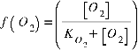
Denitrification | 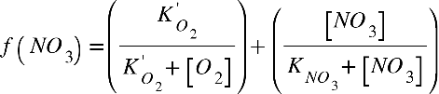
MnO₂ reduction (DMR) | 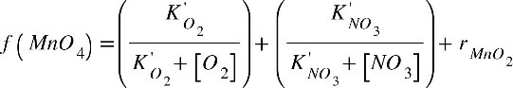
Fe(OH)₃ reduction (DIR) | 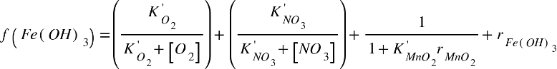
Sulfate reduction
Methanogenesis

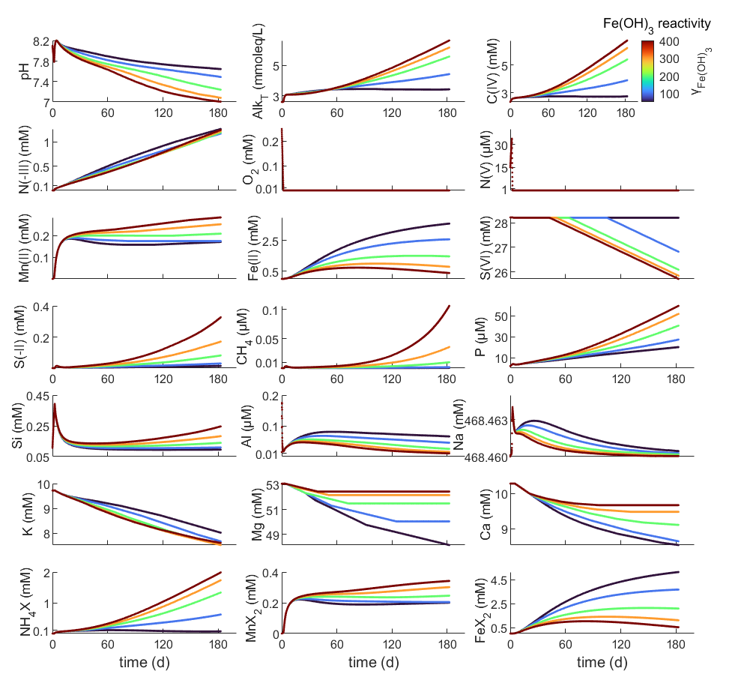
Figure S 1 Evolution of porewater chemistry in the Amz scenario for different Fe(OH)₃ reactivities (γ_{Fe(OH)3}) (PHA setup).

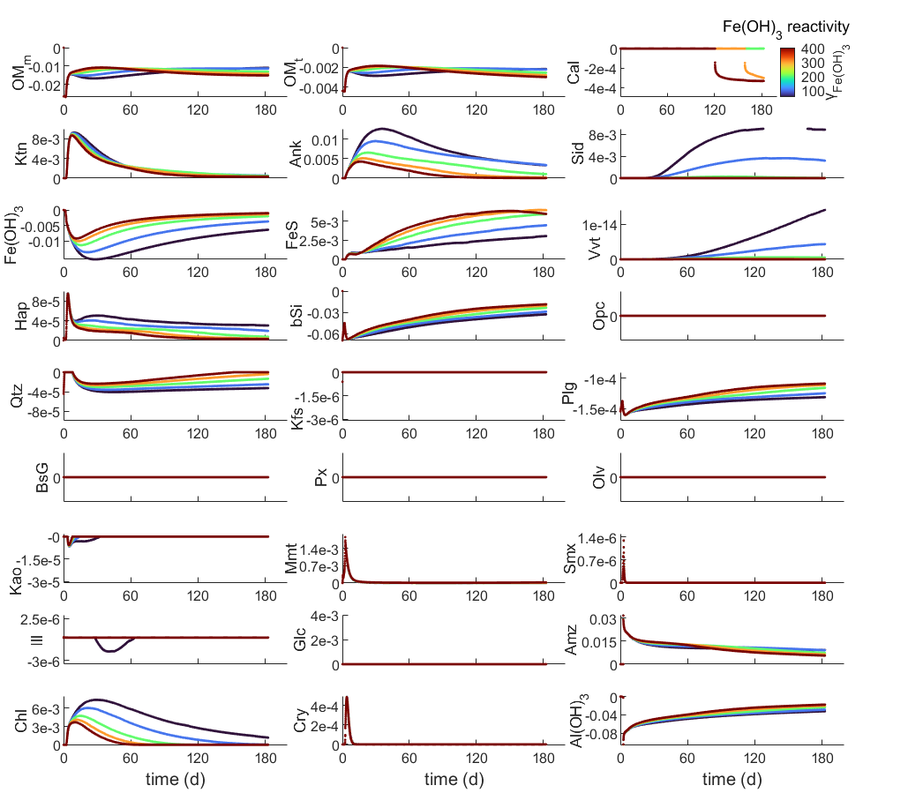
Figure S 2 Evolution of reaction rates (M/yr) in the Amz scenario for different Fe(OH)₃ reactivities (γ_{Fe(OH)3}) (PHA setup).

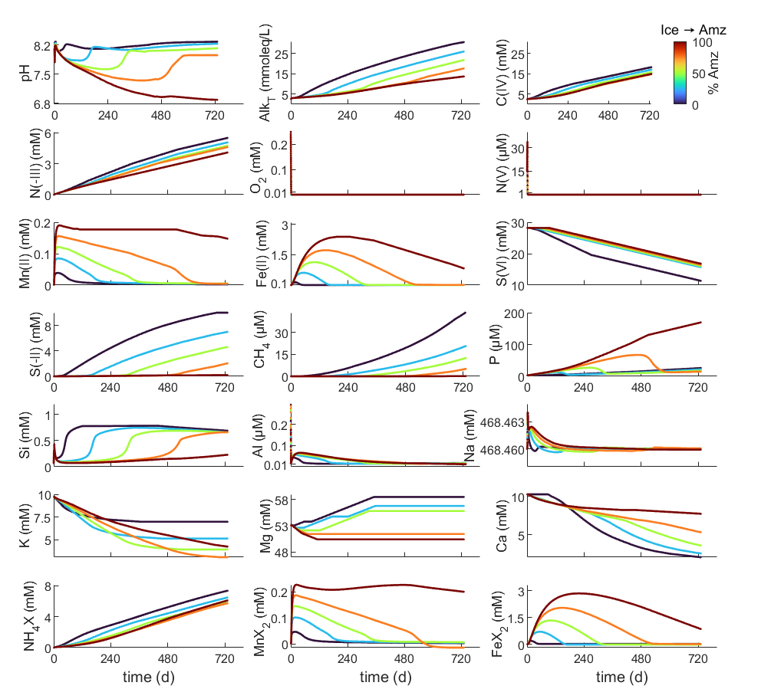
Figure S 3 Evolution of porewater chemistry in a transition from the Amz to Ice scenario (PHA setup).

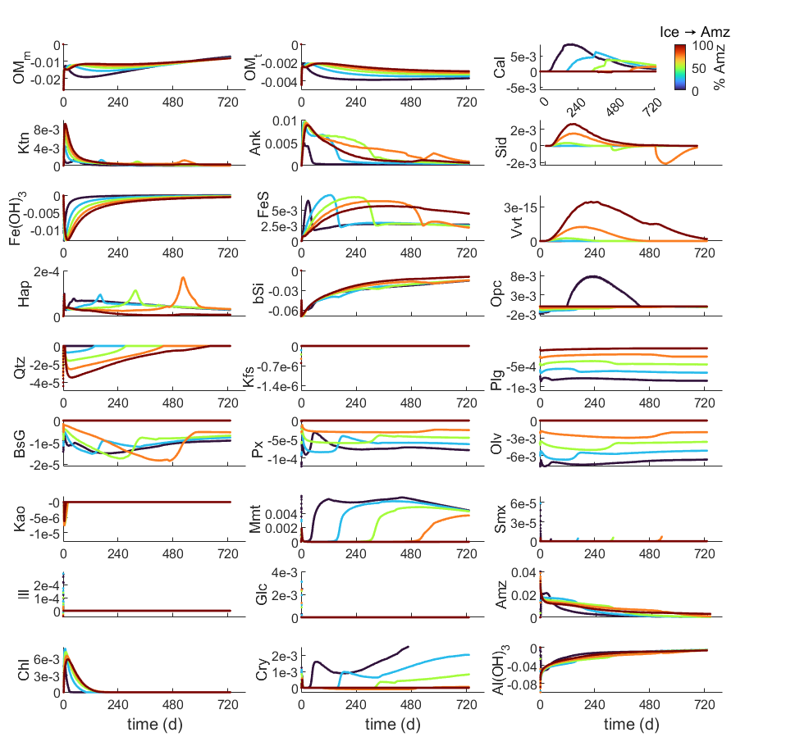
Figure S 4 Evolution of reaction rates (M/yr) in a transition from the Amz to Ice scenario (TIP) setup)

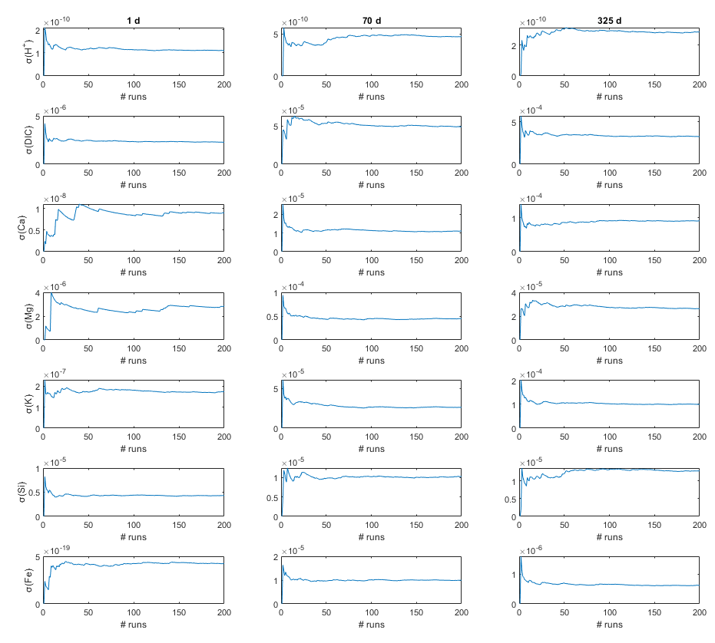
Figure S5 Standard deviations of concentration changes at three time slices as a function of number of perturbations in the TIP setup (30% Amazon, 70 % Iceland, γ_{Fe(OH)3} = 125). Note that standard deviations stabilize, indicating our 200 runs are sufficient to assess the full range of concentration changes for the given scenario.

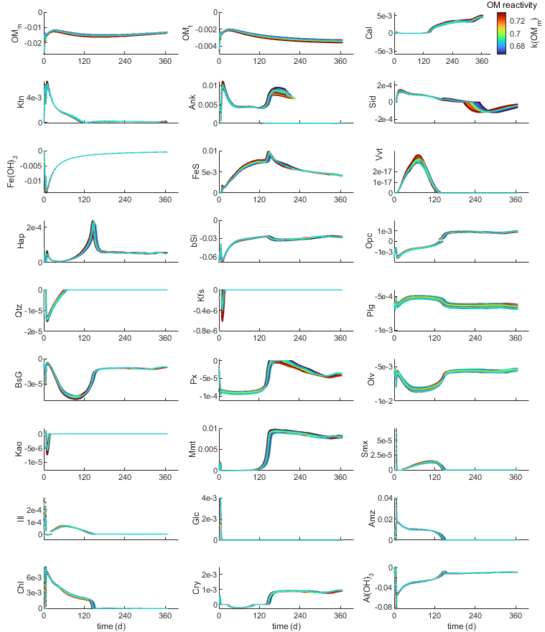
Figure S6 Perturbed reaction rates (M/yr) in the TIP(30% Amazon, 70 % Iceland, γ_{Fe(OH)3} = 125). Colors scale with the linear rate constant of marine organic matter degradation (k_{OmM} in yr⁻¹).
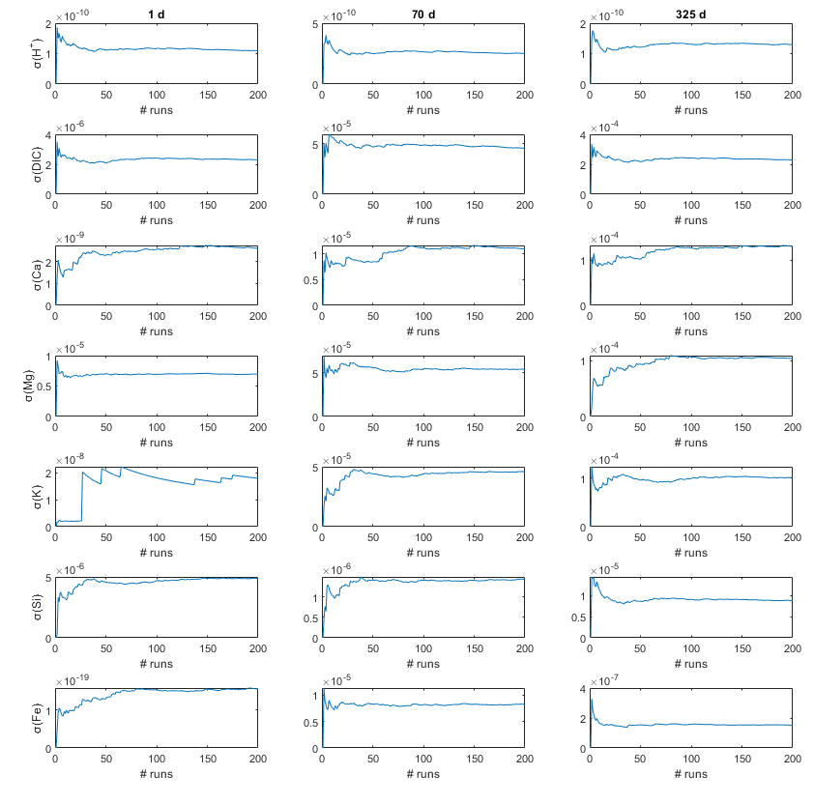
Figure S7 Standard deviations of concentration changes at three time slices as a function of number of perturbations in the PHA setup (30% Amazon, 70 % Iceland, γ_{Fe(OH)3} = 125). Note that standard deviations stabilize, indicating our 200 runs are sufficient to assess the full range of concentration changes for the given scenario.

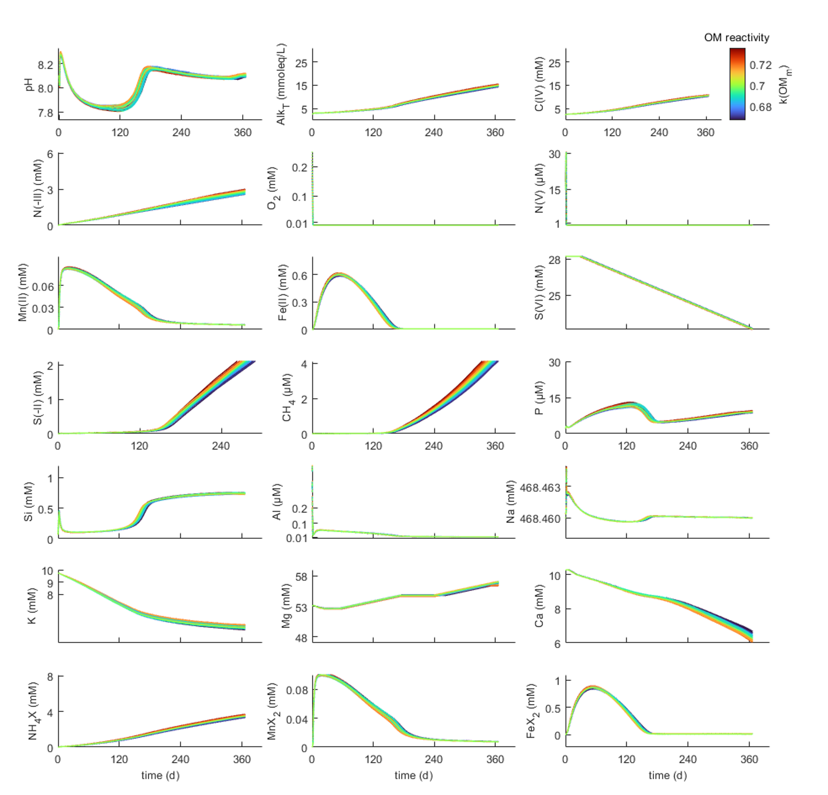
Figure S8 Response of solution chemistry to perturbation in the PHA setup (30% Amazon, 70 % Iceland, γ_{Fe(OH)3} = 125). Colors scale with the linear rate constant of marine organic matter degradation (k_{OmM} in yr⁻¹).
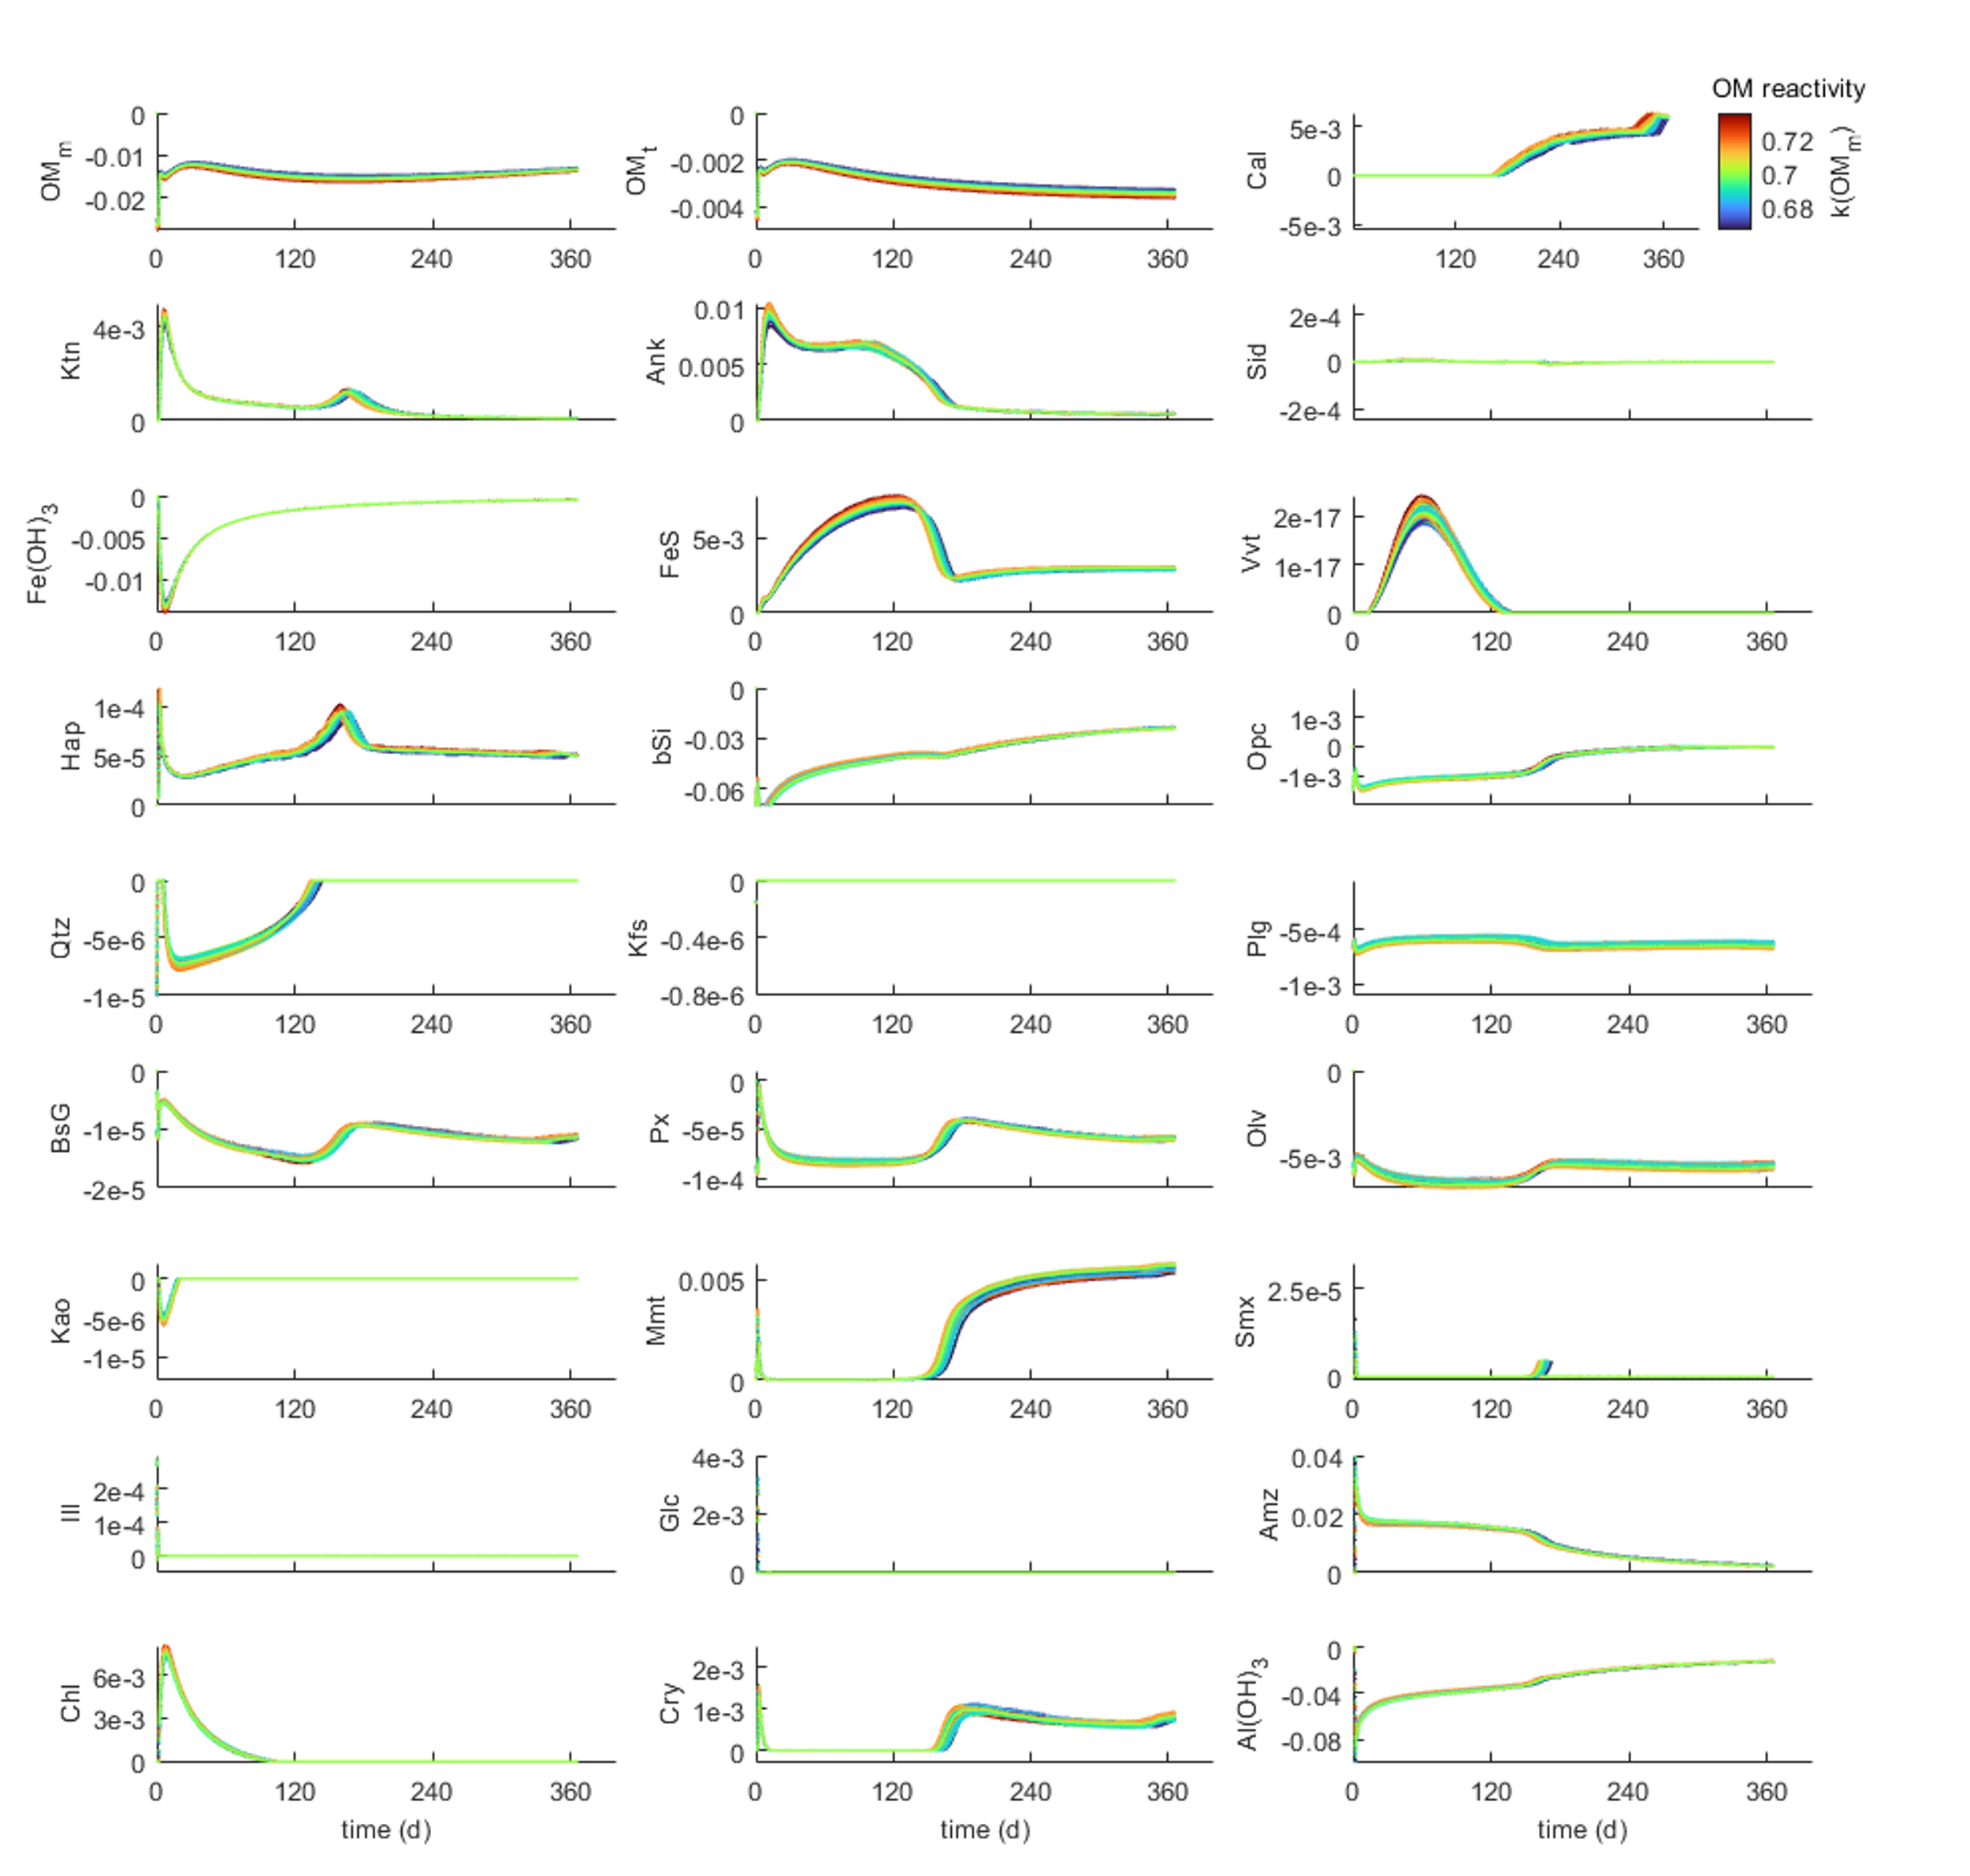
Figure S9 Perturbed reaction rates in the PHA (30% Amazon, 70 % Iceland, γ_{Fe(OH)3} = 125). Colors scale with the linear rate constant of marine organic matter degradation (k_{OmM} in yr⁻¹).
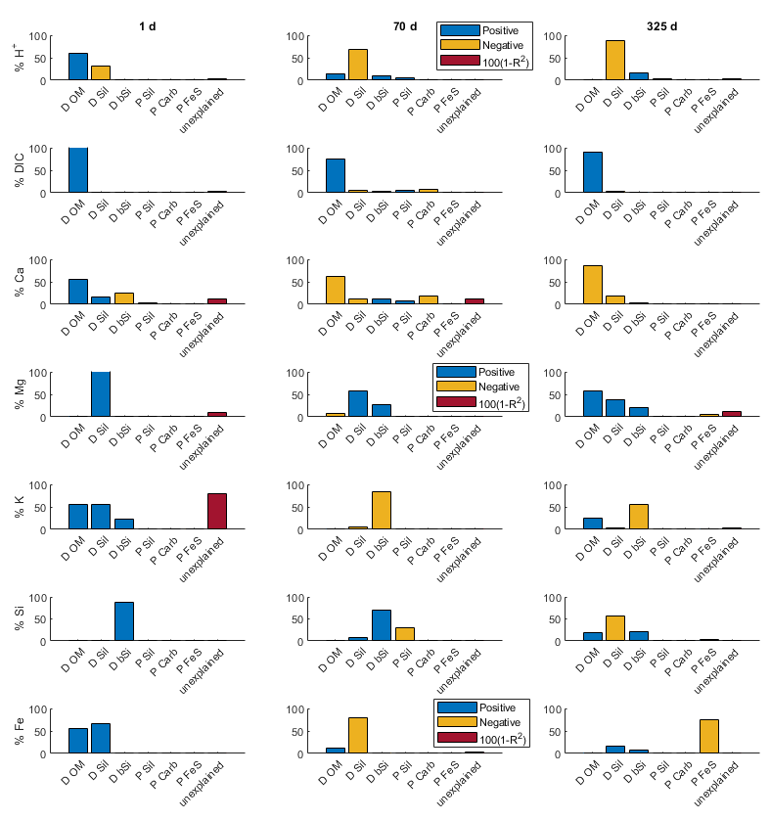
Figure S10 Statistical evaluation (Influence in % = direction(SRC)*(SRC²/R²) of the sensitivity analysis for the PHA setup (30% Amazon, 70 % Iceland, γ_{Fe(OH)3} = 125). Unexplained variability (red) quantifies the amount of interactions and non-linearity in the system. Unexplained variability is excessive for late stage (325 d) K concentrations, rendering this data unreliable.

Supplementary Data S1
Excel spreadsheet ‘SupplementaryData_S1.xlsx’ with details of the model parametrization and corresponding references.

References

Boudreau, B. P. (1996). A method-of-lines code for carbon and nutrient diagenesis in aquatic sediments. Computers and Geosciences, 22(5), 479–496. https://doi.org/10.1016/0098-3004(95)00115-8
Brown, E., Colling, A., Park, D., Phillips, J., Rothery, D. & Wright, J. (2004). Seawater: its Composition, Properties and Behaviour. In Seawater: its Composition, Properties and Behaviour. Butterworth Heinemann and The Open University. https://doi.org/10.1016/c2013-0-10208-5
van Cappellen, P. & Wang, Y. (1996). Cycling of iron and manganese in surface sediments: A general theory for the coupled transport and reaction of carbon, oxygen, nitrogen, sulfur, iron, and manganese. American Journal of Science, 296(3), 197–243. https://doi.org/10.2475/ajs.296.3.197

