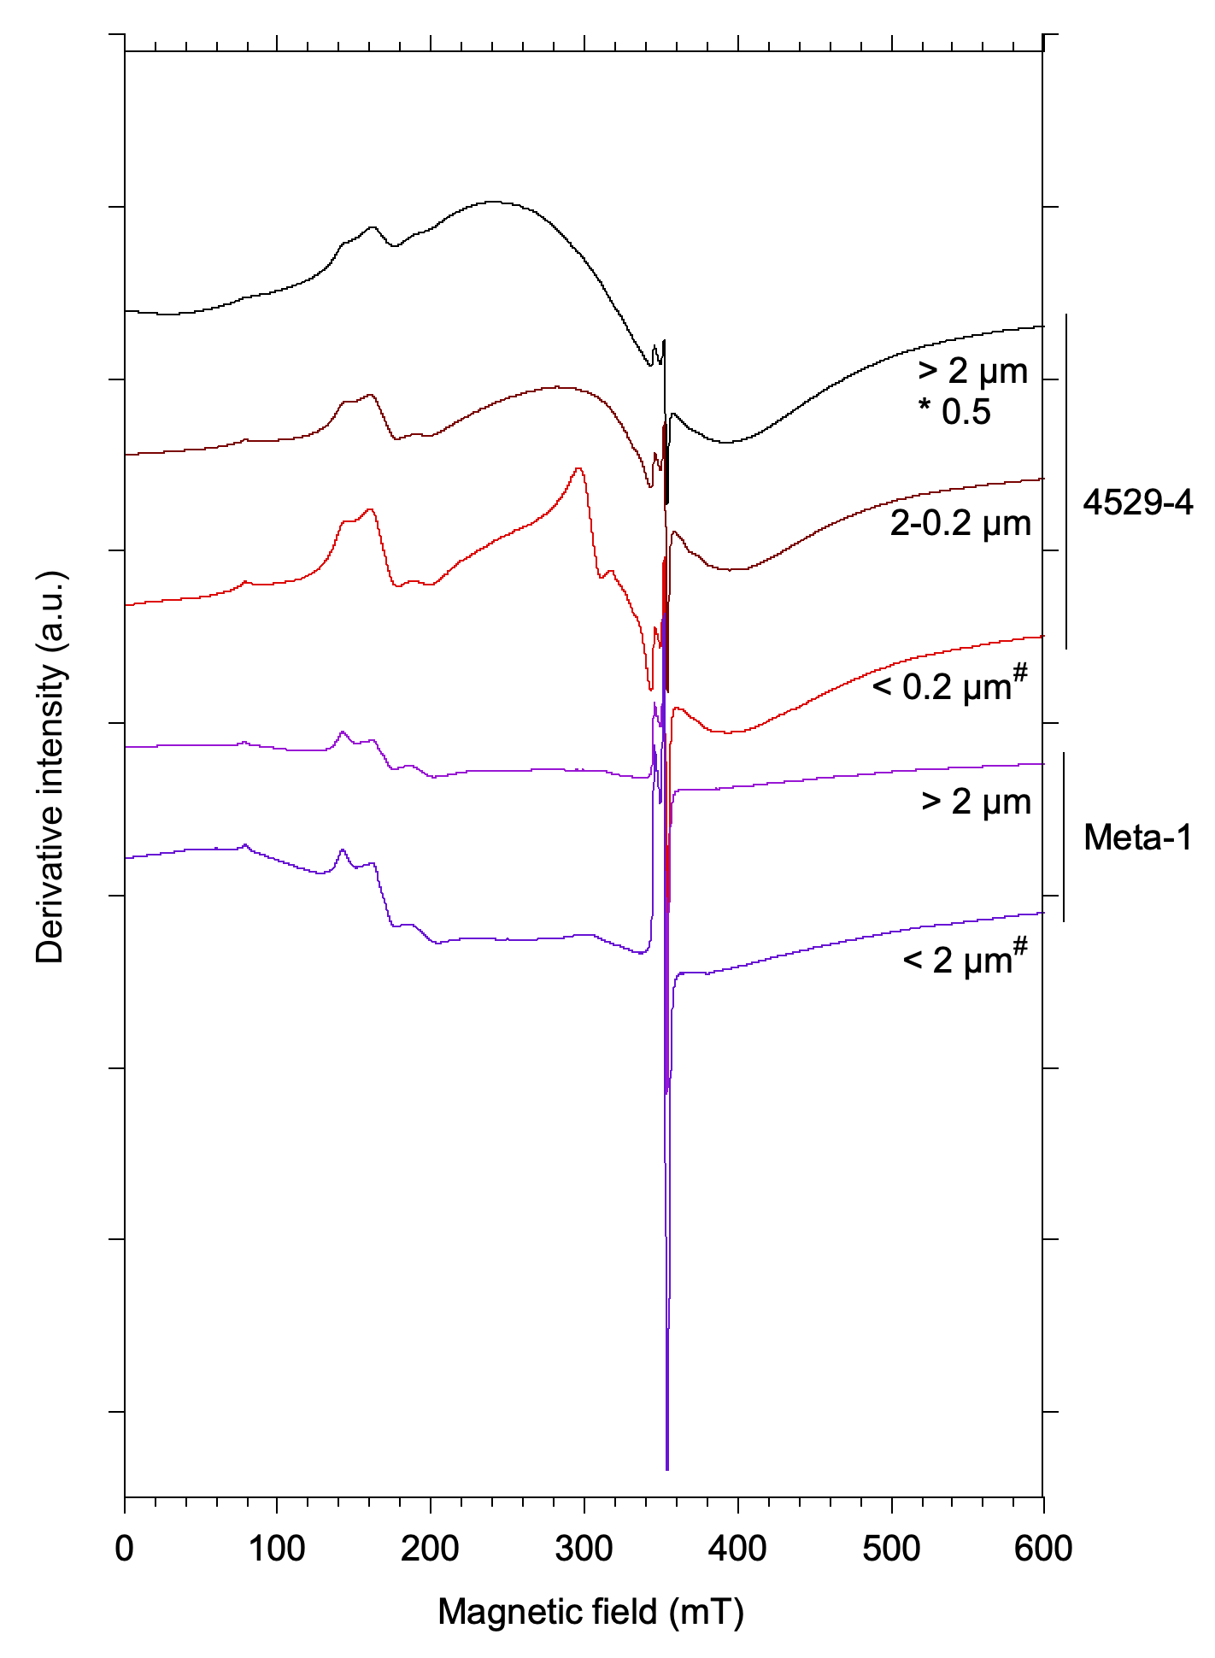

SI-1: Total EPR spectra of Proterozoic kaolinites. (# samples used for dating) normalized according to gain, mass of sample and a constant filling factor of the cavity. The amplitude of the 4529-4 (> 2 µm) spectrum is multiplied by 0.5 to fit with the plot size.

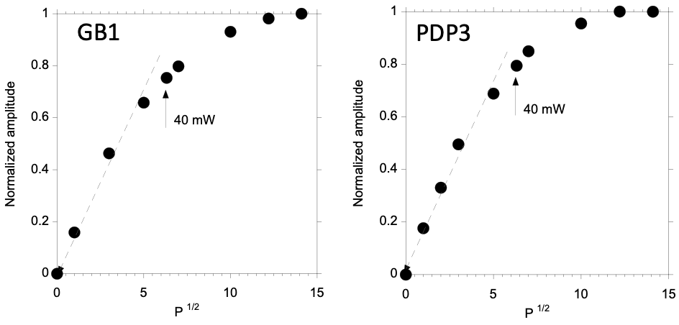

SI-2: Saturation curves of the A-center signal amplitude at room temperature as a function of square root of microwave power for two reference samples: GB1 kaolinite from St Austell, United Kingdom (Allard et al., 1994) and PDP3 (Delineau et al., 1994) from the Charentes Basin, France. Amplitude is normalized to the maximum one. The dotted line is a graphical representation of the linear part of the curve.

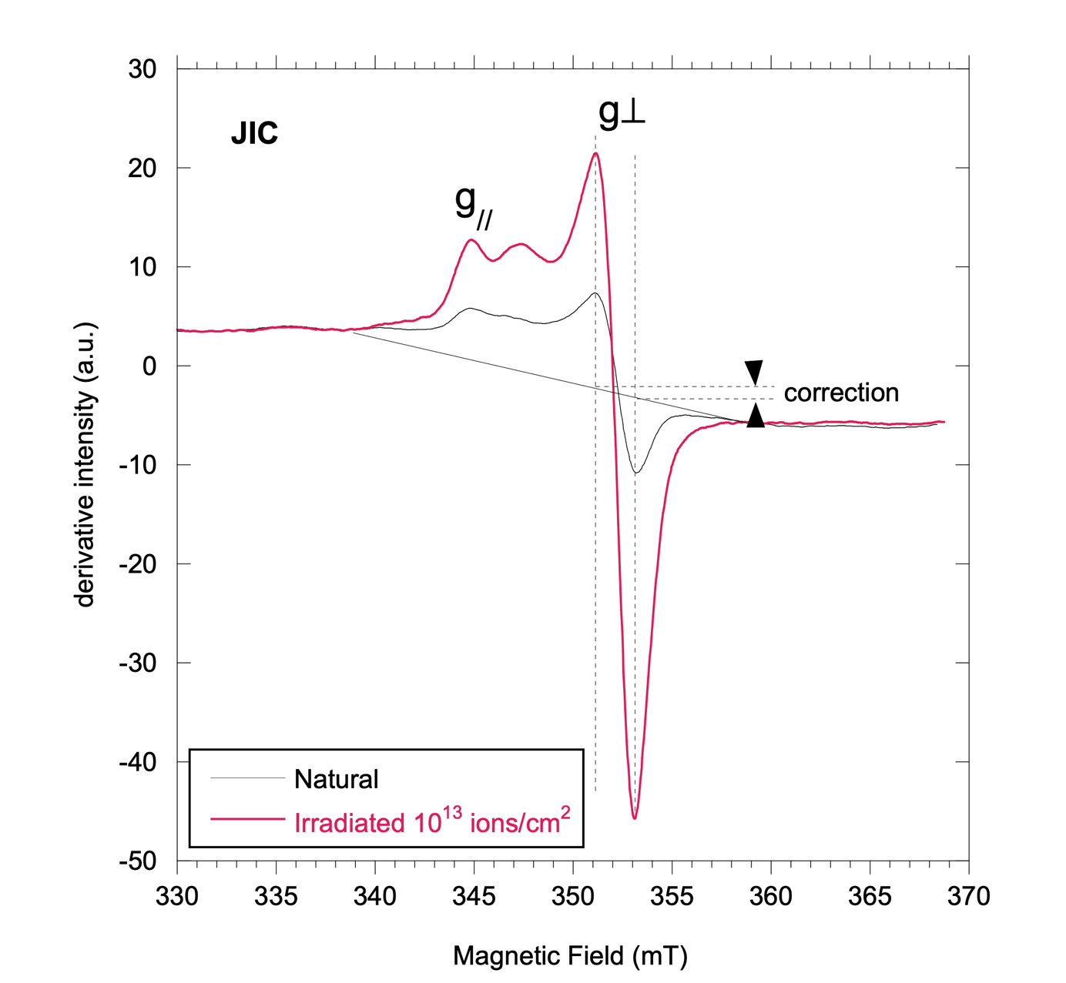

SI-3: Simplified correction of the baseline in the RID region of the EPR spectrum. Example of the RID spectra of the JIC natural and irradiated samples for which the baseline offset is the strongest among the studied sample series. The baseline is taken as a straight line anchored on each side of the RID spectrum and the correction is made at the position of the perpendicular component of the RID signal.

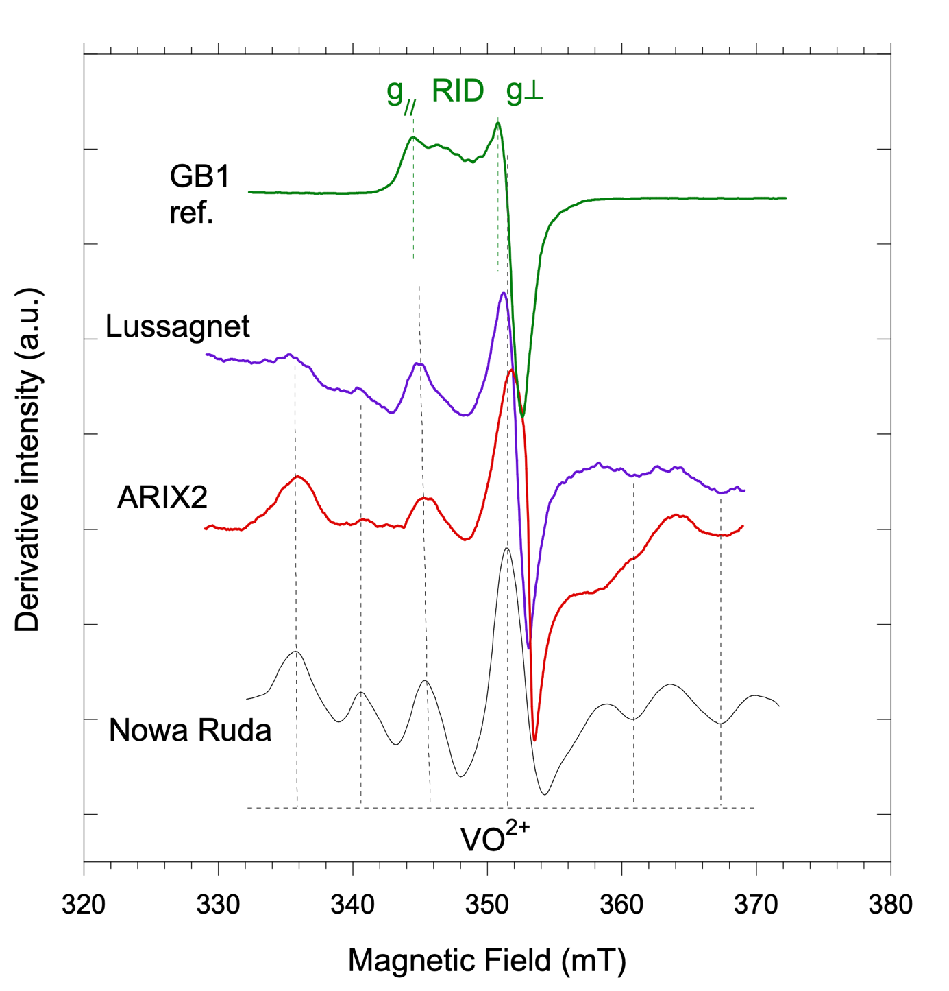

SI-4: Central VO²⁺ (vanadyl) signal in Nowa Ruda kaolinite group clay (Premovic et al., 2012). Its occurrence is revealed in the natural samples ARIX2 and Lussagnet.

SI-5: Matlab codes for (i) fitting growth curves and (ii) Monte Carlo calculation of the error on Paleodose (Dubacq et al. 2012; Mathian M.)

Dosimetry exponential function

% dosi_fitEXP.m
%
% To calculate the constants in the equation Y = m1 (1-exp(-m2(X+m3)))+ m4 (X+m3)
% avec Y = amplitude, X = dose (KGy)
%
% M. Mathian & B. Dubacq, 21-11-2017

% enter the data

data2fit = [%Dose (KGy) Amplitude F3
0, 13.1;
70, 18.25;
140, 20;
234, 21.1;
702, 27.2;
1405, 36.2;
2342, 45.9];

dose = data2fit(:,1);
amplitude = data2fit(:,2);
incert_amp = 10 .* amplitude ./ 100;

%initial values for m1 m2 etc...

fitm = [10, 0.0001, 100]; % contient m1, m2, m3 % valeurs initiales !!!

% fitm = [25, 0.01, 30, 0.001]; % contains m1, m2, m3
m1 = fitm(1); m2 = fitm(2); m3 = fitm(3);
X = [0 : 10 : 2500];% varie de 10 en 10 jusqu'à 2500
eq_model = m1.*(1-exp(-m2.*(X+m3)));

% plot the values
figure,
plot(dose, amplitude, 'kd-','markerfacecolor','y'), hold on
plot(X, eq_model, 'm-'), hold on
xlabel('dose')
ylabel('amplitude')

% defines tolerance and parameters of fit
options = optimset('fminsearch');
options=optimset(options,'TolX',1e-7,'TolFun',1e-4, 'display','off','MaxIter',1e5,'MaxFunEvals',1e5, 'LargeScale','off');%,'HessUpdate','bfgs');% 'DiffMaxChange', Fe3init(1));%, 'LargeScale','off');%,'TypicalX',X0);,'HessUpdate','dfp'

%launches minimization (Nelder-Mead)
[mfitted, residu] = fminsearch('dosiChiEXP', fitm, options, dose, amplitude, incert_amp);% modifier fitm jusqu'à convergence

%check the fitted values
m1 = mfitted(1); m2 = mfitted(2); m3 = mfitted(3);
Xnew = [0 : 10 : 2500];% varie de 10 en 10 jusqu'à 2500
eq_fitted = m1.*(1-exp(-m2.*(Xnew+m3)));

% plot the values
figure,
plot(dose, amplitude, 'kd-','markerfacecolor','y'), hold on
plot(X, eq_model, 'm-'), hold on
plot(Xnew, eq_fitted, 'r-'), hold on
xlabel('dose')
ylabel('amplitude')

%best figure

Xnew = [-200 : 10 : 2500];% varie de 10 en 10 jusqu'à 2500
eq_fitted = m1.*(1-exp(-m2.*(Xnew+m3)));

amp_fitted = m1.*(1-exp(-m2.*(dose+m3)));%valeurs calulées juste pour les points

figure,% en deux volets
subplot(1,2,1)
plot(dose, amplitude, 'kd-','markerfacecolor','y'), hold on
plot(Xnew, eq_fitted, 'r-'), hold on
xlim([-200,2500])
grid on
xlabel('dose')
ylabel('amplitude')
text(500,2,num2str(mfitted))

subplot(1,2,2)
plot(dose, 100*(amp_fitted-amplitude)./amp_fitted, 'kd-','markerfacecolor','y'), hold on
xlabel('dose')
ylabel('erreur en % (surestimé si positif)')

Dosimetry Exponential + Linear function

% dosi_fit.m
%
% to calculate the constants in the equation Y = m1 (1-exp(-m2(X+m3)))+ m4 (X+m3)
% with Y = amplitude, X = dose (KGy)
%
% M. Mathian & B. Dubacq, 21-11-2017

% enter the data

data2fit = [%Dose (Kgys) Amplitude F3
0, 13.1;
70, 18.25;
140, 20;
234, 21.1;
702, 27.2;
1405, 36.2;
2342, 45.9];

dose = data2fit(:,1);
amplitude = data2fit(:,2);
incert_amp = 10 .* amplitude ./ 100;

%initial data for m1 m2 etc...

fitm = [20, 0.003, 60, 0.001]; % contient m1, m2, m3, m4 % valeurs initiales !!!

% fitm = [25, 0.000001, 30, 0.000001]; % contient m1, m2, m3, m4
m1 = fitm(1); m2 = fitm(2); m3 = fitm(3); m4 = fitm(4);
X = [0 : 10 : 2500];% varie de 10 en 10 jusqu'à 2500
eq_model = m1.*(1-exp(-m2.*(X+m3))) + m4.*(X+m3);

% plot the values
figure,
plot(dose, amplitude, 'kd-','markerfacecolor','y'), hold on
plot(X, eq_model, 'm-'), hold on
xlabel('dose')
ylabel('amplitude')

% defines tolerence and fit parameters
options = optimset('fminsearch');
options=optimset(options,'TolX',1e-7,'TolFun',1e-4, 'display','off','MaxIter',1e5,'MaxFunEvals',1e5, 'LargeScale','off');%,'HessUpdate','bfgs');% 'DiffMaxChange', Fe3init(1));%, 'LargeScale','off');%,'TypicalX',X0);,'HessUpdate','dfp'

%launch minimization (Nelder-Mead)
[mfitted, residu] = fminsearch('dosiChi', fitm, options, dose, amplitude, incert_amp);% modifier fitm jusqu'à convergence

%check the fitted values
m1 = mfitted(1); m2 = mfitted(2); m3 = mfitted(3); m4 = mfitted(4);
Xnew = [0 : 10 : 2500];% varie de 10 en 10 jusqu'à 2500
eq_fitted = m1.*(1-exp(-m2.*(Xnew+m3))) + m4.*(Xnew+m3);

% plot the values
figure,
plot(dose, amplitude, 'kd-','markerfacecolor','y'), hold on
plot(X, eq_model, 'm-'), hold on
plot(Xnew, eq_fitted, 'r-'), hold on
xlabel('dose')
ylabel('amplitude')

%best plot

Xnew = [-200 : 10 : 2500];% varie de 10 en 10 jusqu'à 2500
eq_fitted = m1.*(1-exp(-m2.*(Xnew+m3))) + m4.*(Xnew+m3);

amp_fitted = m1.*(1-exp(-m2.*(dose+m3))) + m4.*(dose+m3);%valeurs calulées juste pour les points

figure,% en deux volets
subplot(1,2,1)
plot(dose, amplitude, 'kd-','markerfacecolor','y'), hold on
plot(Xnew, eq_fitted, 'r-'), hold on
xlim([-200,2500])
grid on
xlabel('dose')
ylabel('amplitude')
text(500,2,num2str(mfitted))

subplot(1,2,2)
plot(dose, 100*(amp_fitted-amplitude)./amp_fitted, 'kd-','markerfacecolor','y'), hold on
xlabel('dose')
ylabel('erreur en % (surestimé si positif)')

Monte Carlo code for error calculation on parameters

%====================================================================================================
%
% SIMULATION MONTECARLO
%
%

fitm = [17.9096 0.0221 53.7487 0.0120]; % contient m1, m2, m3, m4 % valeurs initiales !!!

% define tolerence and fit parameters
options = optimset('fminsearch');
options=optimset(options,'TolX',1e-7,'TolFun',1e-4, 'display','off','MaxIter',1e5,'MaxFunEvals',1e5, 'LargeScale','off');%,'HessUpdate','bfgs');% 'DiffMaxChange', Fe3init(1));%, 'LargeScale','off');%,'TypicalX',X0);,'HessUpdate','dfp'

nSimul = 1000;% nombre de simulations

fitMC = NaN.* zeros(nSimul,5);% pour sauver les résultats des fits

for i = 1 : nSimul
uncert = incert_amp .* (2.*rand(size(incert_amp)) - 1);% valeur au hasard à + - un sigma...
new_amp = amplitude + uncert;% ... rajoutée à la donnée pour simuler l'incertitude
%lance la minimisation (Nelder-Mead)
[mfittedMC, residuMC] = fminsearch('dosiChi', fitm, options, dose, new_amp, incert_amp);% modifier fitm jusqu'à convergence
fitMC(i,1:4) = mfittedMC; % sauvegarde les données
fitMC(i,5) = residuMC; % sauvegarde le résidu
end

ok = (fitMC(:,1) < 30) & (fitMC(:,2) < 0.04) & (fitMC(:,3) < 65) & (fitMC(:,4) < 0.02) & fitMC(:,5) < 0.1; % critère de convergence / qualité du fit

Valmoyenne = sum(fitMC(ok,1:4))./nSimul;
Valmedian = median(fitMC(ok,1:4));
StdVal = std(fitMC(ok,1:4));

figure,
subplot(2,3,1)
plot(fitMC(ok,1)), hold on
plot([0,nSimul],[Valmoyenne(1),Valmoyenne(1)],'k--')
plot([0,nSimul],[fitm(1),fitm(1)],'r--')
xlabel('simulation')
ylabel('m1')
subplot(2,3,2)
plot(fitMC(ok,2)), hold on
plot([0,nSimul],[Valmoyenne(2),Valmoyenne(2)],'k--')
plot([0,nSimul],[fitm(2),fitm(2)],'r--')
xlabel('simulation')
ylabel('m2')
subplot(2,3,4)
plot(fitMC(ok,3)), hold on
plot([0,nSimul],[Valmoyenne(3),Valmoyenne(3)],'k--')
plot([0,nSimul],[fitm(3),fitm(3)],'r--')
xlabel('simulation')
ylabel('m3')
subplot(2,3,5)
plot(fitMC(ok,4)), hold on
plot([0,nSimul],[Valmoyenne(4),Valmoyenne(4)],'k--')
plot([0,nSimul],[fitm(4),fitm(4)],'r--')
xlabel('simulation')
ylabel('m4')
subplot(2,3,[3,6])
plot(fitMC(ok,5)), hold on
xlabel('simulation')
ylabel('residu (\chi^2)')

figure,
subplot(2,2,1)
plot(fitMC(ok,1),fitMC(ok,5),'k+'), hold on
plot(fitm(1),residu,'ro','markerfacecolor','r')
xlabel('m1')
ylabel('residu (\chi^2)')

subplot(2,2,2)
plot(fitMC(ok,2),fitMC(ok,5),'k+'), hold on
plot(fitm(2),residu,'ro','markerfacecolor','r')
xlabel('m2')
ylabel('residu (\chi^2)')

subplot(2,2,3)
plot(fitMC(ok,3),fitMC(ok,5),'k+'), hold on
plot(fitm(3),residu,'ro','markerfacecolor','r')
xlabel('m3')
ylabel('residu (\chi^2)')

subplot(2,2,4)
plot(fitMC(ok,4),fitMC(ok,5),'k+'), hold on
plot(fitm(4),residu,'ro','markerfacecolor','r')
xlabel('m4')
ylabel('residu (\chi^2)')

figure,
subplot(2,2,1)
plot(fitMC(ok,1),fitMC(ok,2),'k+'), hold on
plot(fitm(1),fitm(2),'ro','markerfacecolor','r')
xlabel('m1')
ylabel('m2')

subplot(2,2,2)
plot(fitMC(ok,1),fitMC(ok,3),'k+'), hold on
plot(fitm(1),fitm(3),'ro','markerfacecolor','r')
xlabel('m1')
ylabel('m3')

subplot(2,2,3)
plot(fitMC(ok,1),fitMC(ok,4),'k+'), hold on
plot(fitm(1),fitm(4),'ro','markerfacecolor','r')
xlabel('m1')
ylabel('m4')

subplot(2,2,4)
plot(fitMC(ok,2),fitMC(ok,3),'k+'), hold on
plot(fitm(2),fitm(3),'ro','markerfacecolor','r')
xlabel('m2')
ylabel('m3')

figure,
subplot(2,2,1)
hist(fitMC(ok,1),25), hold on
xlabel(['m1 = ',num2str(Valmedian(1)),' +/- ',num2str(StdVal(1))])

subplot(2,2,2)
hist(fitMC(ok,2),25), hold on
xlabel(['m2 = ',num2str(Valmedian(2)),' +/- ',num2str(StdVal(2))])

subplot(2,2,3)
hist(fitMC(ok,3),25), hold on
xlabel(['m3 = ',num2str(Valmedian(3)),' +/- ',num2str(StdVal(3))])

subplot(2,2,4)
hist(fitMC(ok,4),25), hold on
xlabel(['m4 = ',num2str(Valmedian(4)),' +/- ',num2str(StdVal(4))])

SI-6: Errors on concentrations of U, Th, K. All samples measured by ICP-MS from dissolved samples except META-1 and 4925-4 samples that were analyzed by LA-ICP-MS.

Sample | U  ppm | err abs.& | %err* | Th  ppm | err abs. & | %err* | K % | err abs. & | % err@
Illite 43031 | 5.9 | 0.472 | 8 | 6.8 | 0.476 | 7 | 9.71 | 0.486 | 5
Kaolinite META-1 | 2.37 | 0.1896 | 8 | 2.05 | 0.1435 | 7 | 0.22 | 0.04482 | 20
Kaolinite  4925-4 | 2.74 | 0.2192 | 8 | 4.69 | 0.3283 | 7 | 0.48 | 0.09628 | 20
Kaolinite  Lussagnet | 0.53 | 0.053 | 10 | 4.7 | 0.329 | 7 | 0.21 | 0.0415 | 20
Kaolinite  JIC€ | 11.49 | 0.5745 | 5 | 25.28 | 1.264 | 5 | 0.017 | 0.00415 | 25
Kaolinite  ARIX2€ | 10.68 | 0.534 | 5 | 5.22 | 0.3654 | 7 | 0.07 | 0.0166 | 25

* according to errors on trace concentrations from Carignan et al., 2001: uncertainties are the relative standard deviation of the mean.
& absolute error
@ according to the table of errors on concentrations of major elements (on request at SARM, CRPG, Nancy, France).
€ concentrations from Allard et al. (1998)

SI-7: Results of gamma spectrometry on raw samples. Activities are expressed in disintegrations per minute (dpm), with absolute error.

Samples | ²³⁸U dpm/g | Abs.  err. | ²²⁶Ra dpm/g | Abs.  err. | ²²²Rn dpm/g | Abs.  err. | ²³²Th | Abs.  err.
 |  |  |  |  |  |  | dpm/g | Abs.  err. | Ra/U | Rn/U
43031 | 7.97 | 0.3 | 100.09 | 0.81 | 90.61 | 0.24 | 2.09 | 0.1 | 12.56 | 11.37
Meta-1 | 1.1 | 0.1 | 1.44 | 0.25 | 1.34 | 0.04 | 0.15 | 0.1 | 1.31 | 1.22
Lussagnet | 0.46 | 0.05 | 0.69 | 0.1 | 0.56 | 0.02 | 1.22 | 0.03 | 1.50 | 1.22
ARIX2 | 6.89 | 0.16 | 9.38 | 0.36 | 8.29 | 0.09 | 1.29 | 0.06 | 1.36 | 1.20
JIC | 6.98 | 0.24 | 9.73 | 0.57 | 7.11 | 0.11 | 4.69 | 0.15 | 1.39 | 1.02

SI-8: X-ray fluorescence spectra in the Th region for META-1 and Lussagnet samples. Energy is in keV. In META-1 spectrum, the Th contribution in zircon is isolated and can thus be reliably measured. In Lussagnet spectrum the Pb and Rb peaks strongly interfere with the minor Th peak, thus Th contribution could not be reliably determined from the selected region of interest. The fit is in red and the experimental spectrum in blue (Meta-1) or black (Lussagnet).

